**BitPos Retail Solution**

### Version 2.4

**User Manual**

# Table of Contents

1. Product 5
   1. Search Product/View Product List 5
   2. View quantity reserved by BOQ or Sale Order 6
   3. Edit product 7
      1. Add new supplier to product 9
      2. Change the default supplier of the product 9
      3. View product Audit Trail 10
   4. New Product 10
   5. Change Price 11
   6. Price change by import/export 13
2. Customer 15
   1. View customer list 15
   2. Edit customer 16
      1. Define new contact for customer 17
      2. Edit existing contact for customer 18
   3. Customer Statements 18
3. Bill Of Quantity 20
   1. Search for specific BOQ 20
   2. Edit BOQ 22
      1. Edit existing lines 23
      2. Add new products to the BOQ 24
      3. Add item from purchase order 24

3.2.4 Void a BOQ line ........................................................................................................ 25

3.2.5 Print Picking Slip 25

* 1. Generate Purchase Order from BOQ 25
  2. Delete BOQ 26

1. Purchase Order 27
   1. Search/view purchase orders 27
      1. Delete purchase order 29
   2. Create/edit purchase order 29
      1. Add products to purchase order 31
      2. Save purchase order as a draft 31
      3. Submit purchase order 31
2. Good Received 32
   1. Create Received Note 32
      1. Add product from product list 35
   2. View Received Note List/Search for received note 35
3. Sales Transactions 38
   1. Quote 38
   2. Sale Order 40
      1. Invoicing part of sale order 44
   3. Invoice 45
4. Search Sale Order/Quote List 49
   1. Edit Sale Order/Quote 51
   2. Create Purchase Order from Sale Order 51
   3. View linked purchase orders 53
   4. View Invoices/Refunds of purchase order 54
5. Search and view Invoice/Refund List 55
   1. Refund existing invoice 56
6. Cash Management 60
   1. View Cash Session List 60
      1. Adding Float to Register/Till 61
      2. Pickup Float 61
      3. Reconcile Session 61
   2. Cash up Reports 62
7. Debtor Payment 64
8. Accounting 67
   1. Configure Accounting Chart 67
   2. Accounting Report 68
   3. Export to file 70
   4. View exported journals 72
9. Configuration 73
   1. Pricing grades 73
10. Import 74
    1. Import Customer data 74
    2. Import Supplier data 75
    3. Import Products 76
    4. Import BOQ from doors3 77

# Product

System provides facilities for creating new products, modifying current products, search for products and changing product price.

## Search Product/View Product List

Select ‘Product List’ from menu.

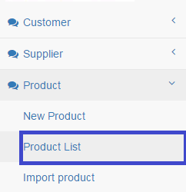

‘Product Search Form’ appears:

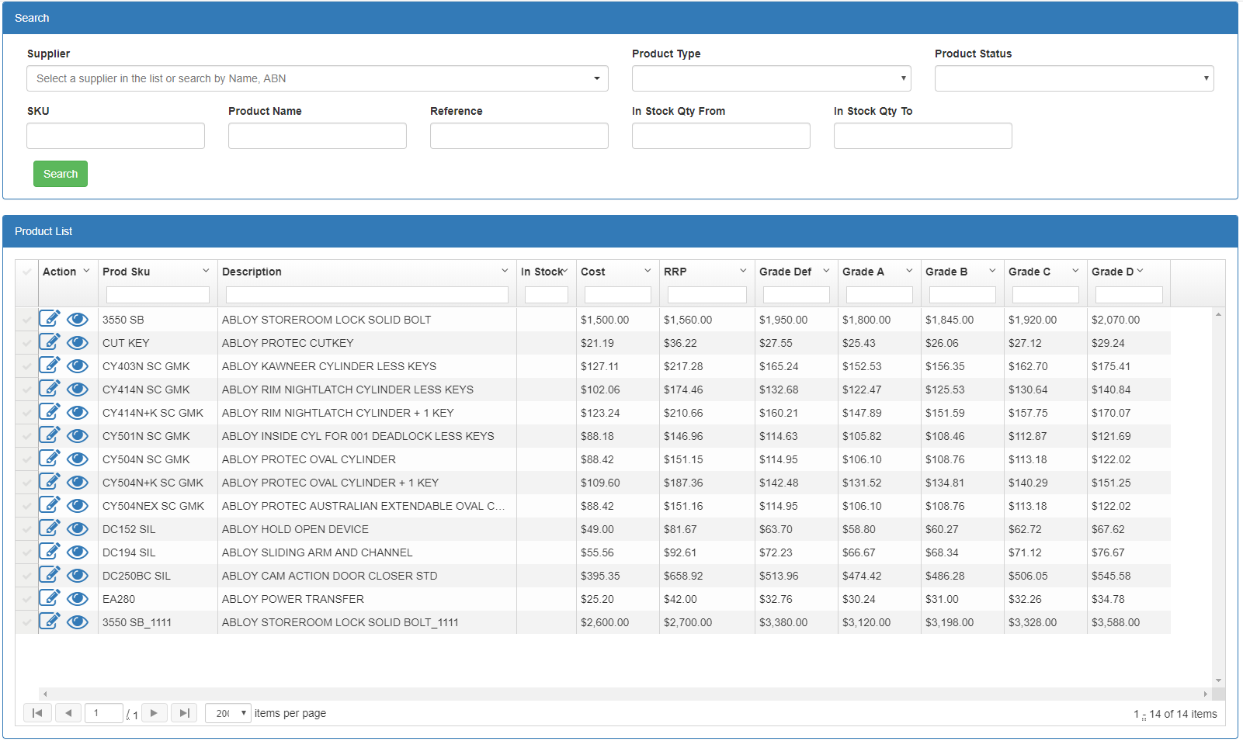

### Field Descriptions:

|  |  |
| --- | --- |
| Field | Description |
| **Search Criteria** | |
| Supplier | Dropdown Box – Limits the display to those products that belongs to the  selected supplier |
| Product Type | Dropdown Box – Limits the display to those products that belongs to the  selected type |
| SKU | Entry Box - Limits the display to those Products that match the entered  SKU. System also displays partially matched products. |

|  |  |
| --- | --- |
| Reference | Entry Box - Limits the display to those products that match the entered  Reference |
| Product Name | Entry Box - Limits the display to those Products that match the entered name |
| In Stock Qty From | Entry Box – search for those products which their available quantity in  stock is bigger than this value |
| In Stock Qty To | Entry Box – search for those products which their available quantity in  stock is lower than this value |
| **Product List –** the empty box beneath each field is for filtering the list. | |
| Prod SKU | Display – product sku |
| Description | Display- Product Description |
| In Stock | Display- quantity available in stock |
| Cost | Display- Product Cost |
| RRP | Display- Recommended Retail Price |
| Grade Def | Display- Product Price for default grade customers |
| Grade A | Display- Product Price for grade A customers |
| Grade B | Display- Product Price for grade B customers |
| Grade C | Display- Product Price for grade C customers |
| Grade D | Display- Product Price for grade D customers |
| Action | * : open the Product for edit   :Open product just for view |
| Navigation Bar | The product list is displayed in multiple page and the first page contains only 25 records. User can navigate to other pages by selecting navigation buttons. |

User can enter the search criteria and then select  button. The result will be displayed in Product List in paging style. The first page which by default contains 25 products is displayed and for consequence pages user can use the navigation bar :

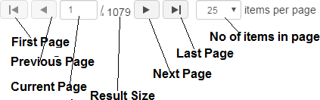

## Edit product

User can edit product by selecting  button from product list. the ‘product page’ appears as following:

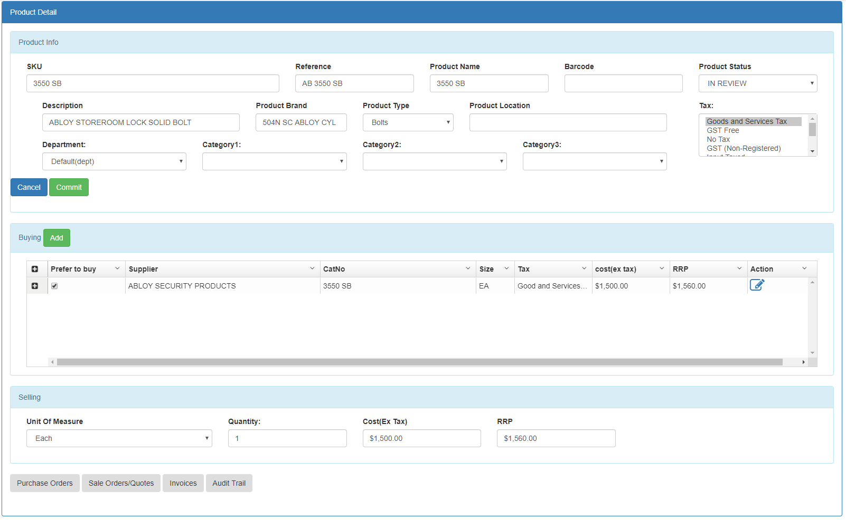

### Field Description

|  |  |
| --- | --- |
| Field | Description |
| **Product Info** | |
| SKU | Entry Box – Product SKU |
| Reference | Entry Box – Product Reference |
| Product Name | Entry Box – Product Name |
| Bar Code | Entry Box – Product Barcode |
| Product Status | Product Status:  : Product is live  : this indicates that product has been imported either from BOQ |
| Description | Entry Box – Product Description |
| Product Brand | Entry Box – Product Brand |
| Product Type | Dropdown Box – Product Type |
| Tax | Dropdown Box(multiple selection) – tax/es applies to product on selling |
| Product Location | Entry Box – Location of product (for example in stock) |
| **Buying –** supplier/s providing this product | |
| Prefer to buy | Checkbox: is this supplier the default supplier of the product. The  product cost and RRP(in selling ) is set based on default supplier |
| Supplier | Display only-supplier of the product |
| Cat No | Display only- Supplier’s Catalogue no assigned to the product |
| Size | Display only - Supplying product size(product size is used in purchasing  the product) |
| Tax | Display only -Tax is applied on product when purchasing |
| Cost(ex tax) | Display only- product cost excluding tax |
| RRP | Display only- product recommended retail price |
| Action | : edit the supplier information |
| **Selling – this section is for selling product(quote, sale order and invoice)** | |
| Unit of Measure | Dropdown – product size used for selling |
| Quantity | Entry Box- quantity of product in case |
| RRP | Entry Box – Retail Reviewed Price |
| Tax Included | Check Box – indicates if tax is included in cost or not. |
| **Buttons on the page** | |
|  | Save the changes and submit the form |
|  | Ignore all the changes and return to the product list |
|  | Displays all purchase orders containing this product |
|  | Display all Sale Orders/Quotes containing this product |
|  | Display all the Invoices containing this product |
|  | Display all the Audit trail(transactions made on this product) of  this product |

User can edit product information, buying or selling information and then select 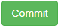 button.

### Define new product supplier

As mentioned, system supports defining multiple suppliers of product. For this means user need to select 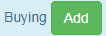 button in ‘Buying’ section. The following page will be displayed:

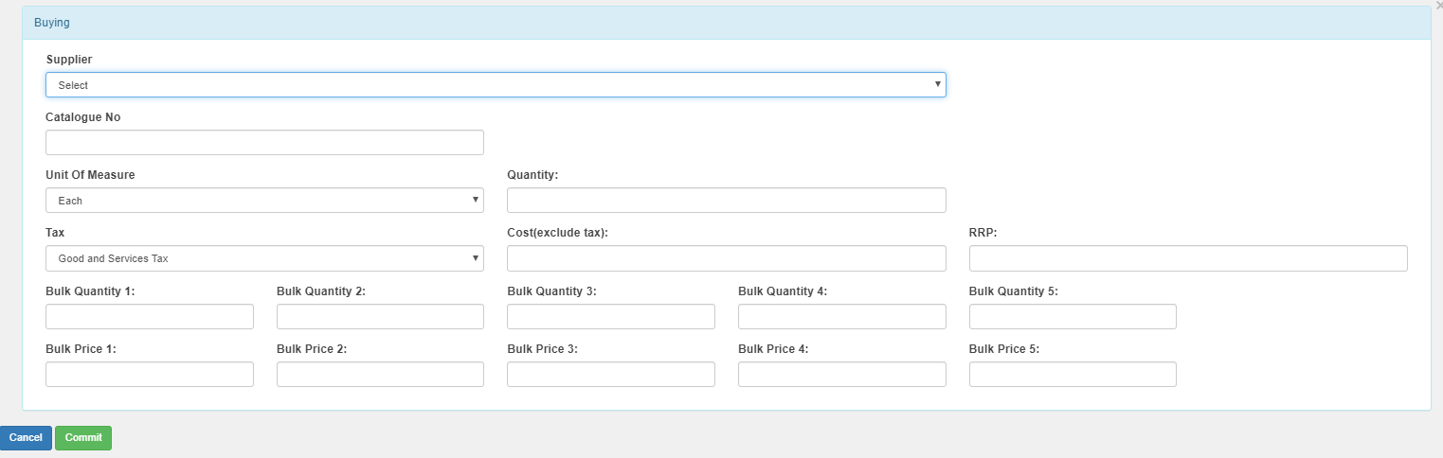

|  |  |
| --- | --- |
| Supplier | Dropdown-supplier of the product |
| Catalogue No | Entry Box- Supplier’s Catalogue no assigned to the product |
| Part No | Entry Box- Supplier’s part no assigned to the product |
| Unit of measure | Dropdown - Supplying product size(product size is used in purchasing the  product) |
| Quantity | Entry Box- Quantity of product in case(pack) |
| Tax | Dropdown -Tax is applied on product when purchasing |
| Cost(exclude tax) | Entry Box- product cost excluding tax |
| Bulk Quantity & Bulk  Price 1 to 5 | Entry Box- special prices for bulk quantities. |

After entering the required information user can select  button. System will add the supplier to the product supplier list:

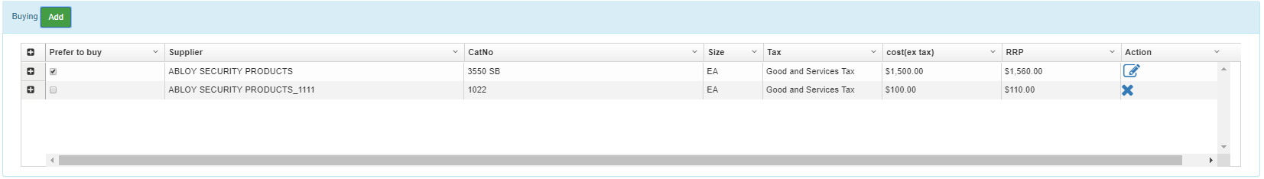

### Change the default supplier of the product

By selecting the ‘Prefer to buy’ column from ‘Buying’ section, user can change the default supplier of the product. Changing the supplier also will change the product cost(ex tax) and product RRP and new values will be used in all future transactions.

### View product Audit Trail

By selecting 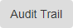 button, user can see the Audit Trail information of the product. Audit Trail includes all the transactions that affect the product quantity/price.

User can view the detail of each transaction affected the product quantity/price by selecting  icon.

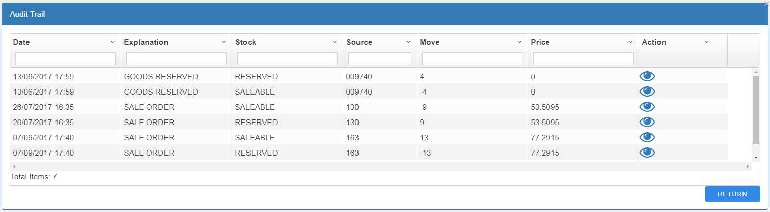

## New Product

For defining new products, select ‘New Product’ from Product menu.

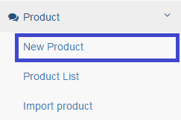

The ‘Product’ page appears with blank values. User can enter the product value and then select ‘Commit’ button. The product page for ‘new product’ is exactly the same as ‘Edit Product’ page.

Please refer to ‘Edit Product’ section for more details.

**Before adding a new product system checks if there is existing product with the same SKU and Reference**. If matching product found then ask user permission for continuing or cancelling the process.

## Change Price

This option is used when user wants to change product price for specific supplier. From product menu select ‘Change Price’

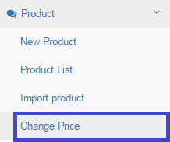

‘Change Price’ form appears as below:

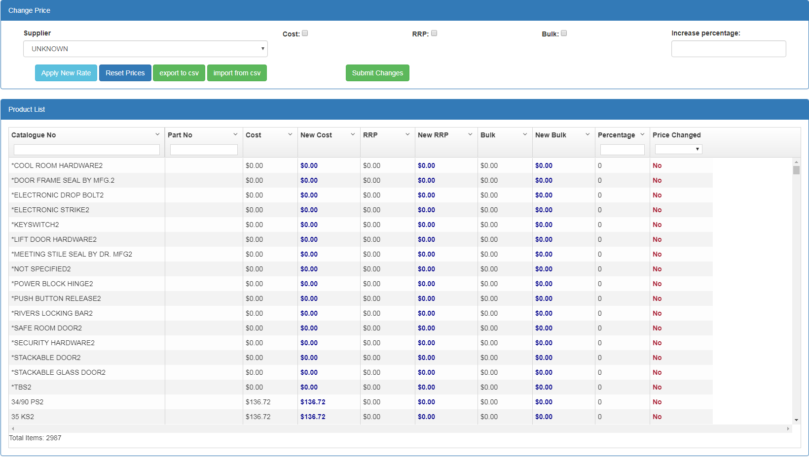

By changing supplier from supplier dropdown list, all the supplier products will be appear in the list.

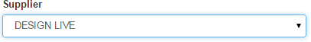

### For changing the price:

1. Select a supplier from the supplier dropdown list. All the products belong to that supplier will be appeared on the ‘Product List’
2. You can select the products you want to change their prices by entering the filtering value in ‘Catalogue No’

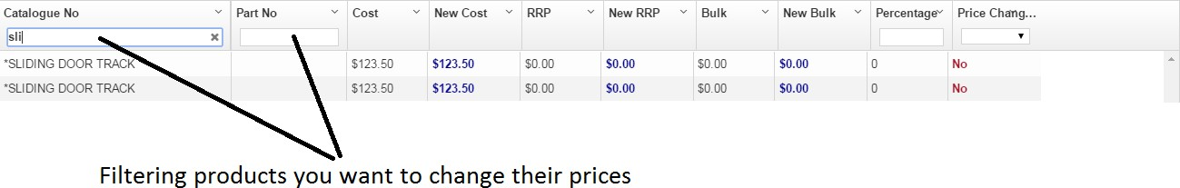

1. Select the price type you want to change(cost, RRP or bulk price) and then enter the percentage amount in ‘Increase Percentage’ box:
2. Select ‘Apply New Rate’ button. This will change the selected price for selected products. You can see the new prices in product list (New Cost, New RRP and New Bulk – displayed in blue color)

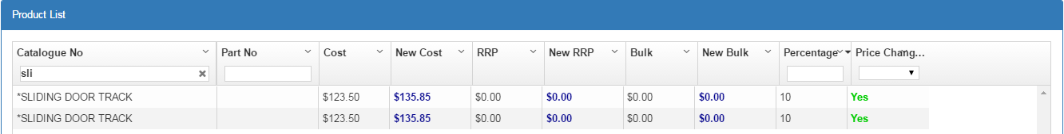

1. You can repeat step 2 to 4 to change prices for another set of products. You can also filter the affected products from ‘Price Change’ dropdown list in product list. The value ‘yes’ means price is changed and the value ‘no’ means price has not changed for that product:

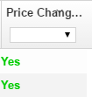

1. You can filter all the products which their price has been changed, by selecting ‘Yes’ from ‘Price Change’ filter and review the price change.
2. You can also manually change the price by entering new values in ‘New Cost’, ‘New RRP’ and ‘New Bulk’ fields.
3. If you want to reset the price change to initial value, just select ‘Reset Price’ button. The prices will be reset to its initial value.
4. All the changes you have done so far is temporary saved on the page. If you want to apply changes on the server just click ‘Commit’ button.

## Price change by import/export

System also provides this facility to export the current products of specific supplier in csv file, change the price on the exported file and then import new prices.

From product menu select ‘Change Price’



‘Change Price’ form appears as below:

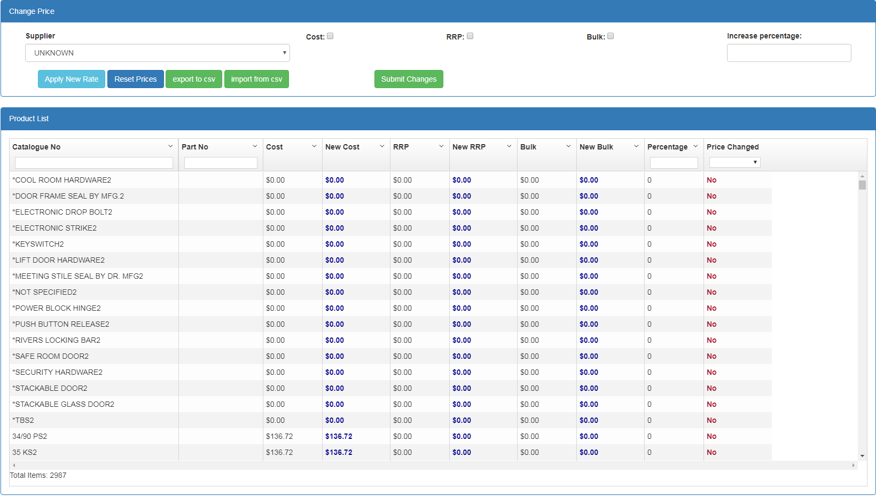

By changing supplier from supplier dropdown list, all the supplier products will be appear in the list.



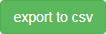

To export the selected supplier’s product, click on button. System export the products in csv format as below:

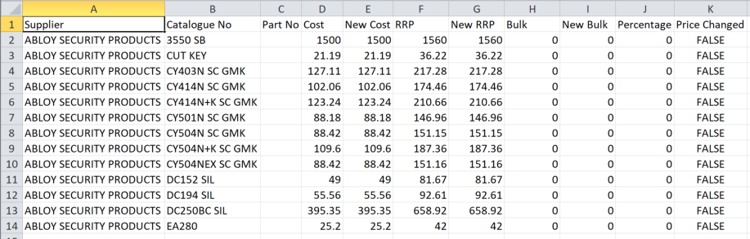

User can open the exported csv file in Excel and set new price(by entering new values in ‘New Cost’, ‘New RRP’, ‘New Bulk’ columns).

### Note: user is not allowed to change the 2 first columns (Supplier and Catalogue No)

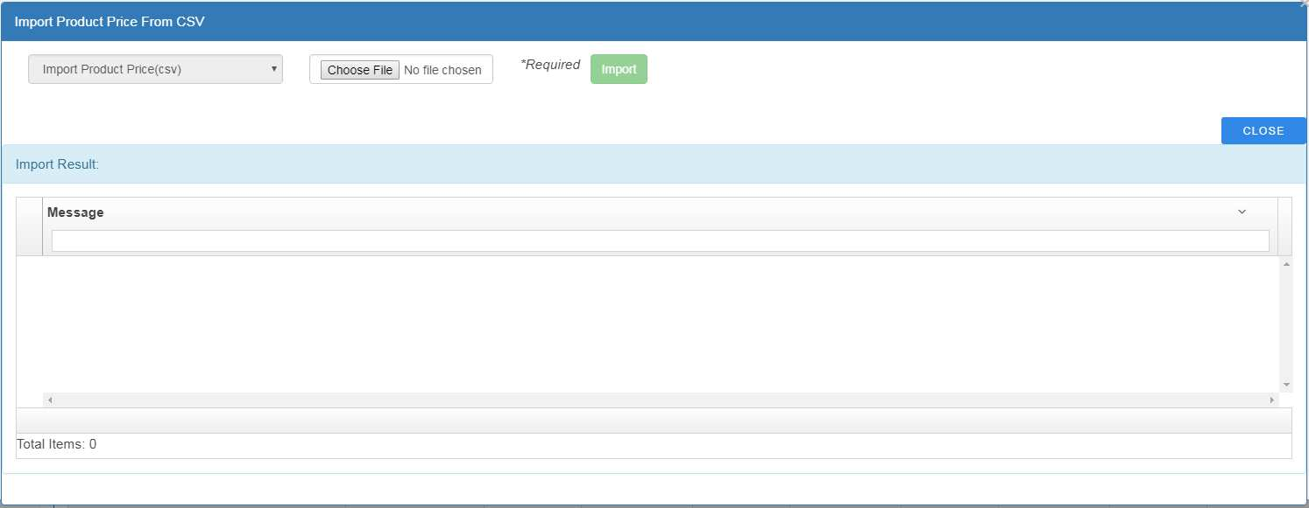After setting new prices, user can import new file into system by selecting 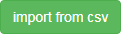 button. System displays the following page:



User need to choose file from file system by clicking on and then selecting option. The new price will be imported to the system and result will be displayed in “Import Result” section.

By selecting  button, user can return to the ‘change price’ page and see the results.

# Customer

System provides facilities for defining new customer, searching customers and modifying the customer profile.

## View customer list

Select ‘Customer List’ from customer menu:

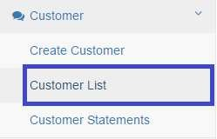

System displays customer list as following:

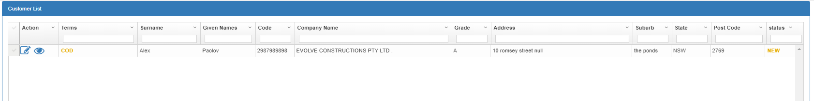

### Field Description

|  |  |
| --- | --- |
| Field | Description |
| **Customer List** - the empty box beneath each field is for filtering the list | |
| Terms | Display- customer type:  : Account Customer – this type of customer can be assigned credit and sale transactions can be paid from Account.  : Cash Only Customer |
| Surname | Display- Customer representative surname |
| Given Name/s | Display- Customer representative given names |
| Code | Display-ABN number or customer code |
| Company Name | Display-company name |
| Grade | Display-customer grade |
| Address, suburb, state, postcode | Display- customer’s address |
| Status | Display- customer status in the system:   * : Customer profile has been imported(via BOQ) and yet to be confirmed   : customer profile is reviewed by authorized user |

User can filter the list by entering the values in the boxes beneath the columns



## Edit customer

To edit an existing customer, select button from the customer list for that specific customer. The ‘Customer page’ for editing appears as following:

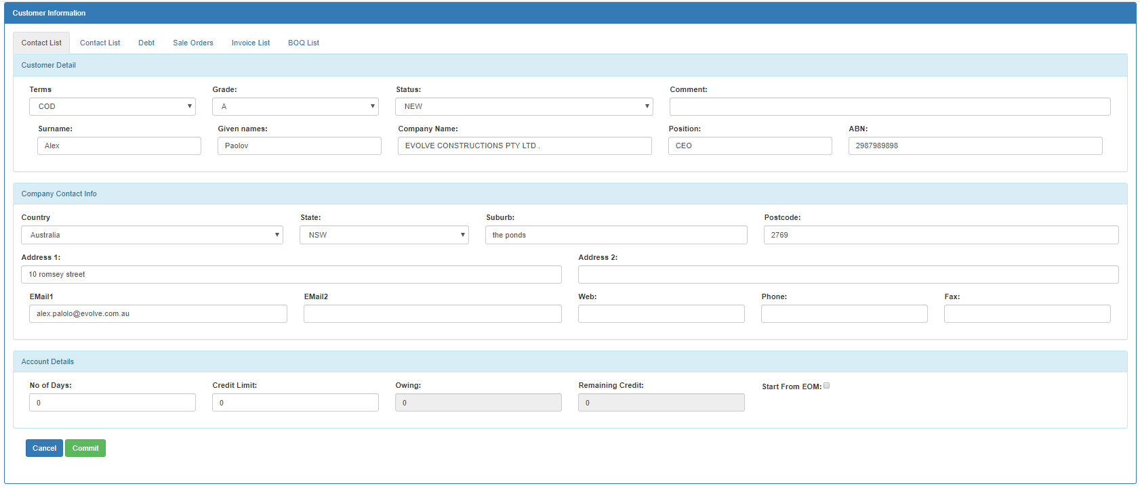

### Field Description

|  |  |
| --- | --- |
| Field | Description |
| **Customer Information** | |
| Terms | Dropdown- - customer type:  **Acc** : Account Customer – this type of customer can be assigned credit and sale transactions can be paid from Account.  **New**: Cash Only Customer |
| Grade | Dropdown – Customer Grade. This grade is using for selling price of products. Please refer to Configuration- Pricing grades: |
| Status | Product Status:  NEW: Customer profile has been imported(via BOQ) and yet to be confirmed  **Active**: customer profile is reviewed by authorized user and is confirmed  **On-hold**: Customer is on-hold. System doesn’t allow performing sale transaction on on-hold customers.  **In-active:** Customer is being inactived. |
| Comment | Entry Box – Any comment on customer record. For example why  customer is being on-hold |
| Surname | Entry Box – Customer contact person surname |
| Given names | Entry Box – Customer contact person given names |
| Company Name | Entry Box – Company Name |
| Position | Entry Box – Customer contact person position |
| ABN | Entry Box – ABN |

|  |  |
| --- | --- |
| **Account Detail** | |
| Credit Limit | Entry Box- The credit limit assigned to the customer. only applicable for  ACC customers. |
| No Of Days | Entry Box- No of days the customer should pay off after doing a transaction. No of day can be calculated based on the following dates:   1. Start from End of Month (in which the invoice is issued) 2. Start from Invoice Date |
| Start From EOM | Checkbox- if ticked the No of Days is calculated from End of Month  otherwise calculated based on the transaction date |
| Owing | Display- the amount customer owe company |
| Remaining Credit | Display- the remaining credit of customer account. |
| **Company Contact Info** | |
| Address(country, state, suburb, postcode and address) | Entry Box- Customer Postal Address |
| Email | Entry Box- Customer email address. this email address is used in invoice  page to send invoice to customer as pdf |
| Web | Entry Box- customer web page |
| Phone | Entry Box- customer phone |
| Fax | Entry Box- customer fax |
| **Additional Information(tabs on the main page)** | |
| Contact List | Tab-page : user can define multiple contact for customer. For example  project manager … |
| Debt | Tab-page: displays all the customer debt including due date, invoice no,  debt amount and balance |
| Sale orders | Tab-page: displays all sale orders of this customer |
| Invoice List | Tab-page: displays all invoices issued for this customer |
| BOQ List | Display all Bill Of Quantity belongs to this customer |
| **Buttons on this page** | |
|  | Save the changes and submit the form |
|  | Ignore all the changes and return to the product list |

### Define new contact for customer

In ‘Customer’ page – additional information tab, select ‘Contact List’. System displays current contact list as below:

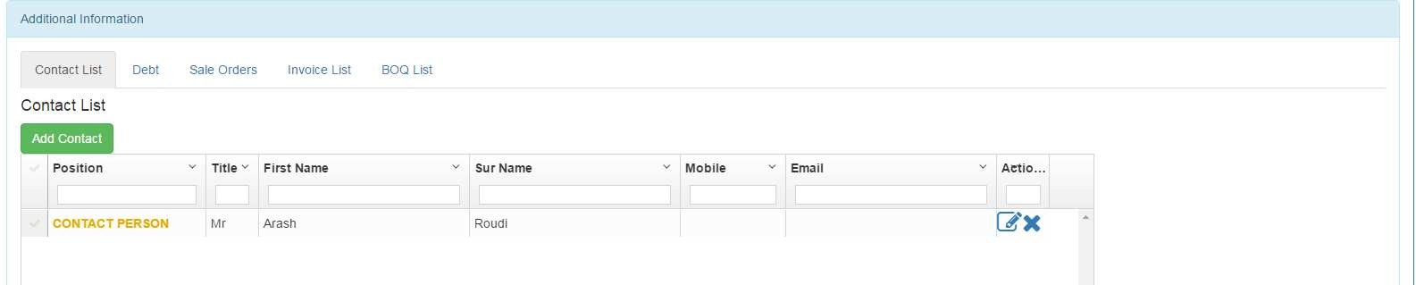

To define a new contact, select 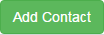 button. System display ‘Add Contact’ page as below:

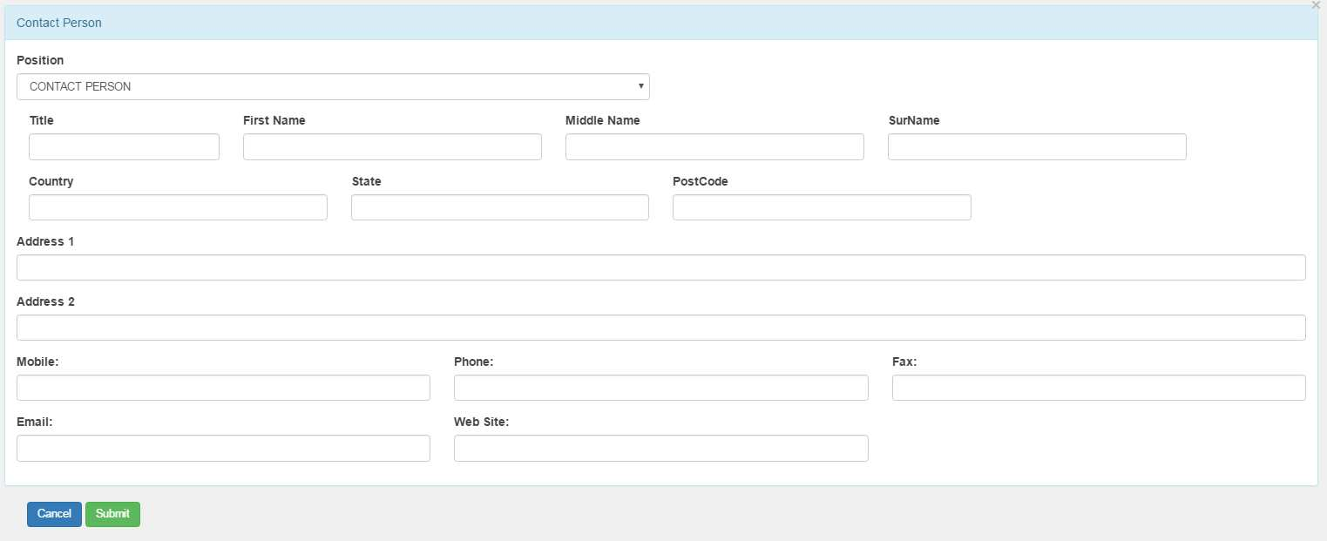

Enter the required field and then select the button. System add the contact to the customer.

### Edit existing contact for customer

Select  button from contact list. System displays current contact info. User can modify the contact info and then select the  button.

## Customer Statements

To view customer statements report, select ‘Customer Statements’ from Customer menu:

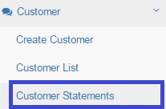

System displays ‘Customer Statements’ page as below:

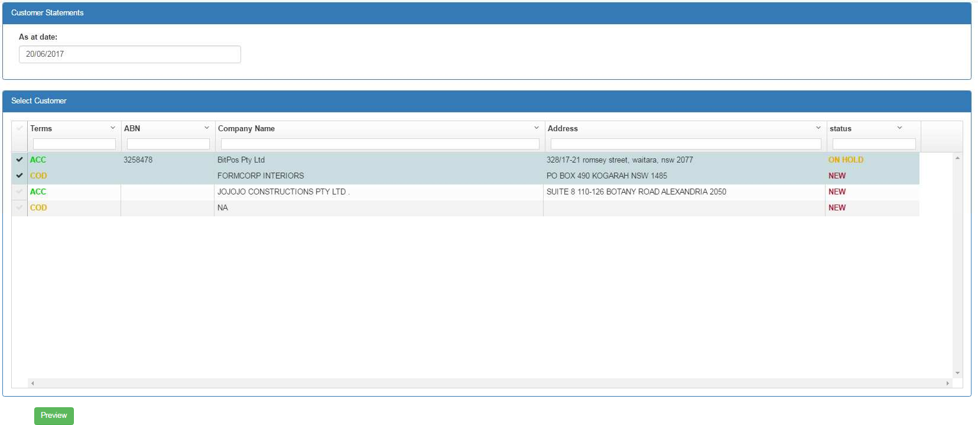

Enter a date in ‘As a date’ field, select one or more customers (or select all by ticking  on header) and then select  button. System displays ‘Customer Statements Report’ for selected customers based on the entered value for date:

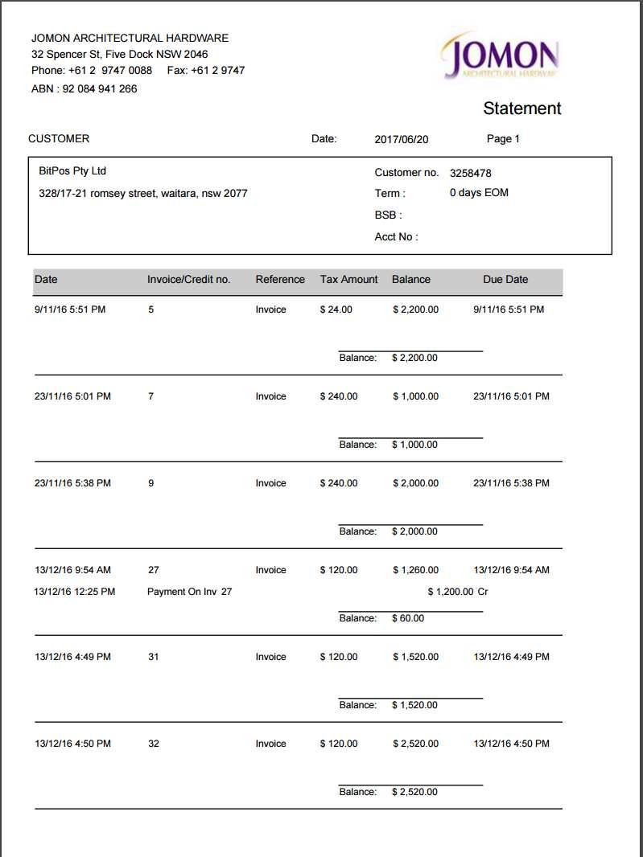

# Bill Of Quantity

Bitpos solution accepts Bill Of Quantity data in xml format from Door3. After importing BOQs, user can generates purchase orders from multiple BOQs.

# Import Bill Of Quantity

To import boq in xml format:

1. From the menu, select ‘Import BOQ’

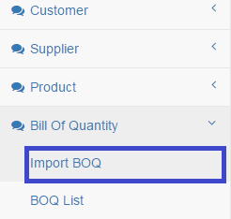

1. System displays ‘Import Bill Of Quantity’ page which includes current imported BOQs and a box for selecting and uploading new BoQ.

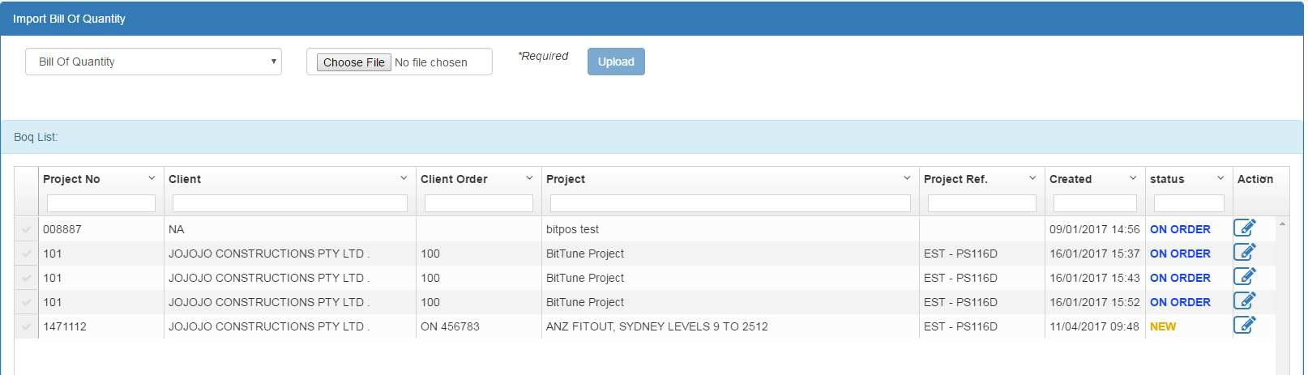

1. Select Doors3 exported BOQ from your file system by selecting ‘Choose File’ option and then select ‘Upload'
2. The new BoQ will be imported to the system and will appear on the list. The status of all new BOQ is set to ‘PENDING in red color



Importing a BOQ into system will import new suppliers, products and customers. These new inserted data will be held in temporary state until the user confirms the BOQ. The status of new imported BOQ is ‘PENDING’ and will be in red color.

User has the following options after importing BOQ

1. View BOQ detail: review the BOQ detail
2. Edit BOQ : edit BOQ detail if needed
3. Confirm BOQ: confirm BOQ. By confirming the BOQ all the related imported data like Clients, Suppliers and Products appears on the system.
4. Delete BOQ: delete the BOQ from the system.

## Search for specific BOQ

System provides facility to search specific BOQs based on range of specific fields. Select ‘BOQ List’ from menu:

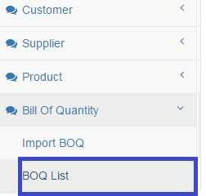

A list of recent imported BOQs appears with search options

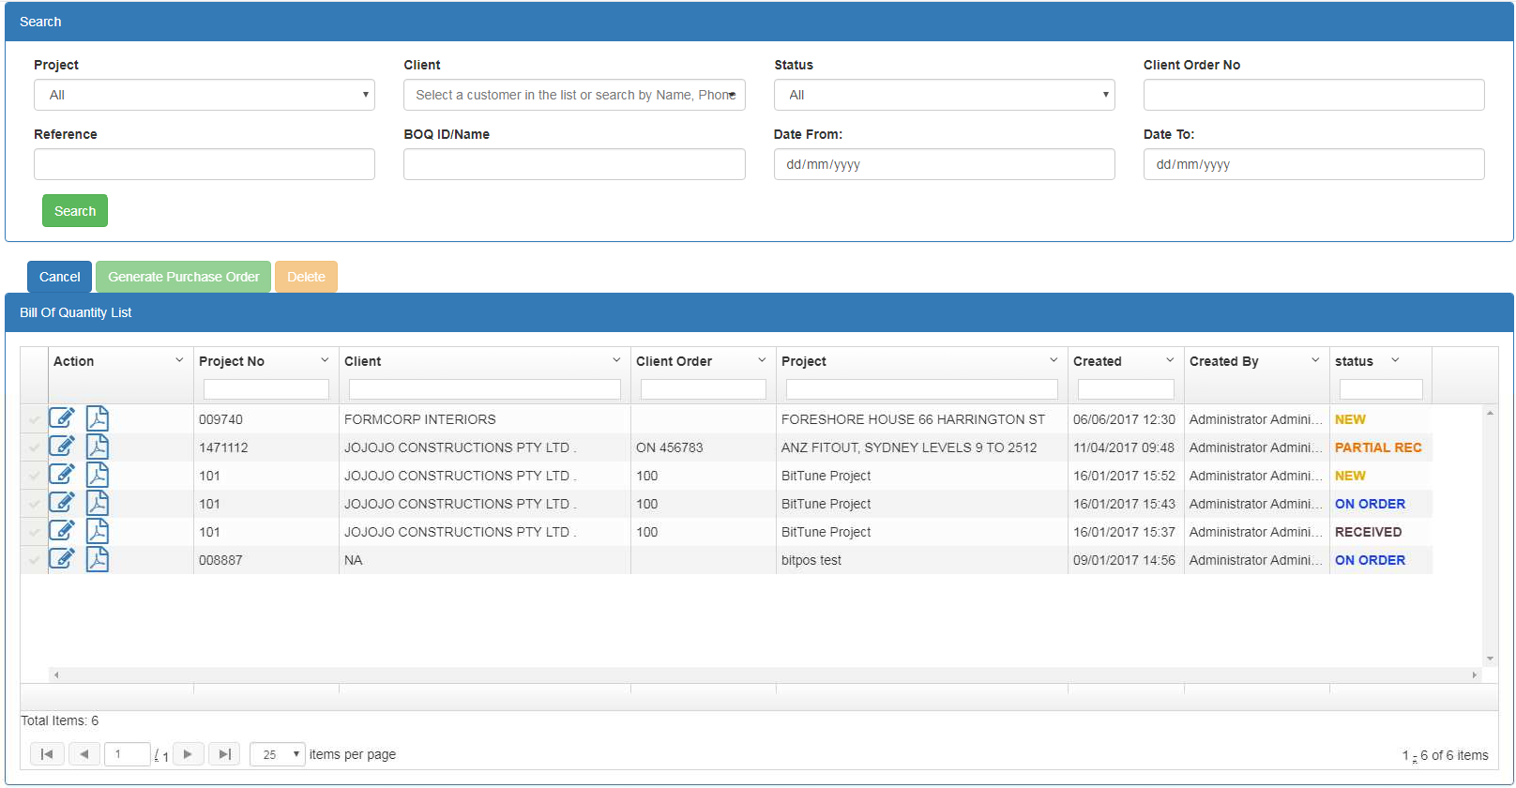

### Field Descriptions

|  |  |
| --- | --- |
| Field | Description |
| **Search Criteria** | |
| Project(name) | Dropdown Box – Limits the display to those BOQs that belongs to the  selected project name |
| Client | Dropdown Box- Limits the display to those BOQs that belongs to the  selected client |
| Status | Dropdown Box- Limits the display to those BOQs that are in selected  status |
| Client Order No | Entry Box - Limits the display to those BOQs that match the entered  Client Order No |
| Reference | Entry Box - Limits the display to those BOQs that match the entered  Reference |
| BOQ ID/Name | Entry Box - Limits the display to those BOQs that match the entered  ID/Name |
| Date From | Date Box - Limits the display to those BOQs that creation date is after  value entered for Date From |
| Date To | Date Box - Limits the display to those BOQs that creation date is before  value entered for Date To |
| **Bill Of Quantity List –** the empty box beneath each field is for filtering the list | |
| Project No | Display – Configured Project No associated with the BOQ |
| Client | Display- Configured Client associated with the BOQ |
| Client Order | Display- Configured Client Order No associated with the BOQ |
| Project(name) | Display- Configured Project Name associated with the BOQ |
| Created | Display- Creation Date(Import date) associated with the BOQ |
| Created By | Display-The user responsible for importing the BOQ |
| Status | * : the BOQ is imported to the system but not confirmed. in this state, system keeps the related BOQ data like suppliers, client and products in temporary mode until user confirm the BOQ. Until after confirming BOQ these data can be viewed and used in system. * : the BOQ is confirmed and the related data(suppliers, client and products) are usable in system. * : A purchase order/s has been created from the BOQ but good has not been delivered   : Part of BOQ lines (some of its products or some quantities of its products) has been received.  : All the BOQ products have been received. |

## Edit BOQ

User can do the following modifications to the Imported BoQ

1. add Items from Purchase Orders or from products
2. For BoQ items, change stock qty or stock location or put comment for each item To edit new imported BOQ:

Locate the BOQ by following steps from ‘Search for specific BOQ’ section and select specific BOQ form the list by clicking on option. The BOQ detail appears as below

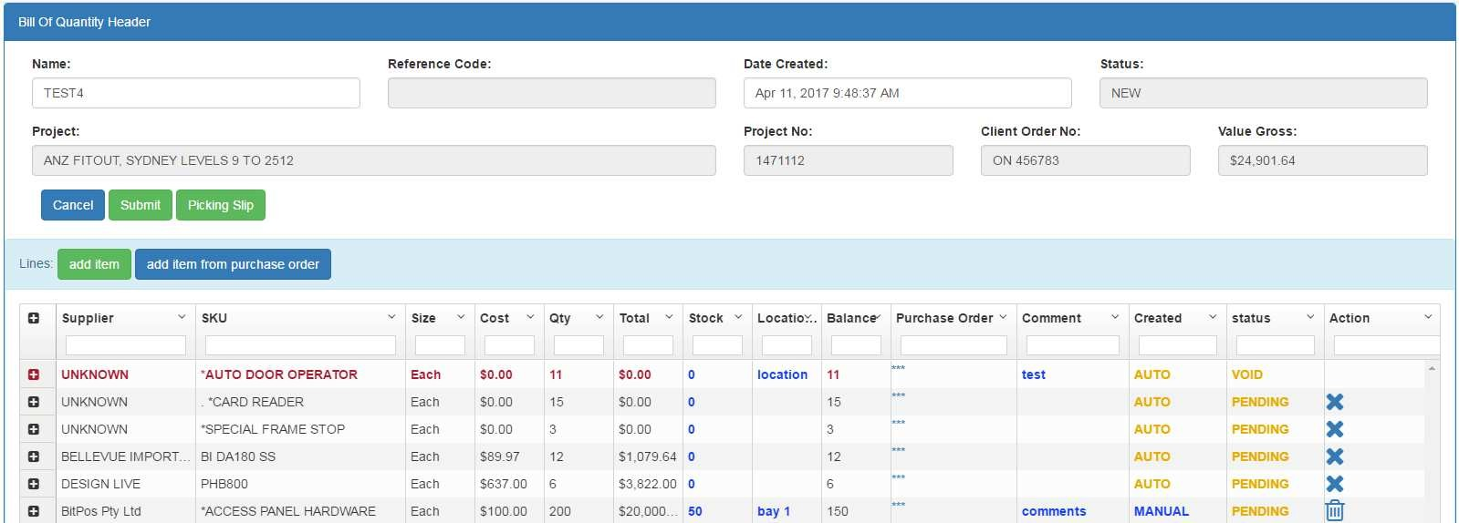

### Field Description

|  |  |
| --- | --- |
| Field | Description |
| **Bill Of Quantity Header** | |
| Name | Entry Box –ID or name assigned to the BOQ. After importing, user can  change the BOQ Name. |
| Reference Code | Display Only Box- Reference code assigned to the BOQ. |
| Date Created | Display Only Box- the date BOQ is imported |
| Project | Display Only Box – Project name BOQ is created for |
| Project No | Display Only Box - Project code BOQ is created for |
| Client Order No | Display Only Box – Client Order No assigned to the BOQ |
| Value Gross | Display Only Box – Total Gross value of the BOQ |
| Status | : the BOQ is imported to the system but no further action done on it  : A purchase order/s has been created from the BOQ but good |



|  |  |
| --- | --- |
|  | has not been delivered  : Part of BOQ lines (some of its products or some quantities of its products) has been received.  : All the BOQ products has been received. CANCELLED: NA  FINALISED: NA |
| **Bill Of Quantity List –** the empty box beneath each field is for filtering the list | |
| Supplier | Display – Supplier name associated with BOQ line |
| SKU | Display- Product SKU of BOQ line |
| Size | Display- BOQ line unit(each, kg,g,litter…) |
| Cost | Display- BOQ line final cost |
| Qty | Display- Quantity needed for BOQ line |
| Total | Display-Total cost(Qty multiply Cost) of BOQ line |
| Stock | Entry box – In stock quantity for BOQ line |
| Location | Entry box – In stock location quantity for BOQ line |
| Balance | Display – Auto calculated field indicates the quantity needed for the  BOQ line to be purchased (Qty – Stock) |
| Purchase Order | Display – purchased order assigned to the BOQ line. This field is set when user creates purchase order from BOQ/s or user add line to the  BOQ from existing Purchase Order by clicking on |
| Comment | Entry box – Comments user enters for the BOQ line |
| Created | Display – Created Method which includes  :the BOQ line is imported from doors3  : the BOQ line is added manually after importing by  or |
| Status | : the BOQ line is imported to the system but no further action done on it  : A purchase order/s line has been created from the BOQ line but good has not been delivered  : Part of BOQ lines (some of its products or some quantities of its products) has been received.  : All the BOQ line has been received.  : BOQ line is voided and not be purchased |
| Action | : Botton - void the item – only available for BOQ line. When voided, the BOQ line colour turns red and that item will not be purchased  : Botton - remove the manually added lines. This option is only available for manually added boq lines. By selecting this option, the related line will be deleted from the list. User can not remove original  BOQ lines(lines imported from doors3) |
|  |  |

### Edit existing lines

You can only modify limited columns for each BOQ line. These columns highlighted by blue colour and include ‘Stock’, ‘Location’ and Comment.

### Add new products to the BOQ

User can add lines to BOQ from existing products. For this select 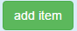 option. The following page displays

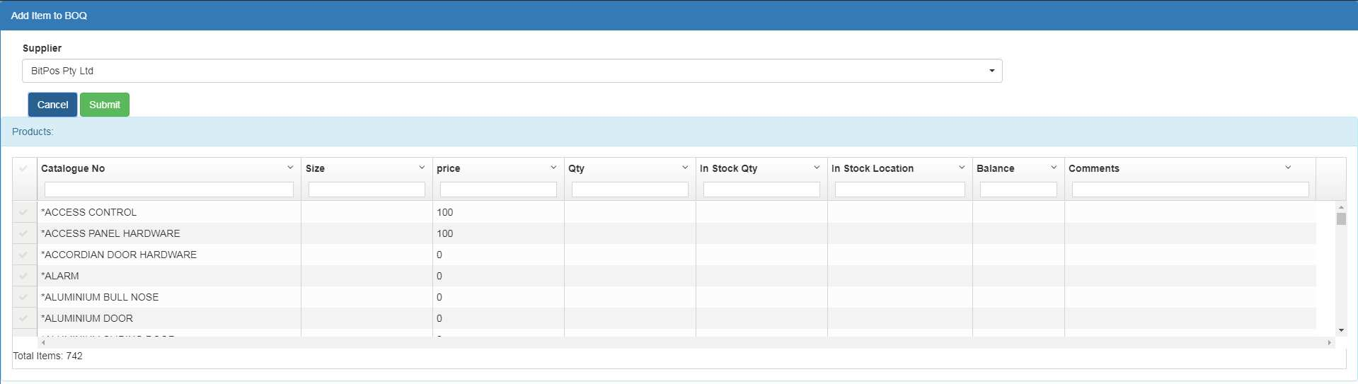

By selecting a ‘Supplier’ , all the products related to the supplier appears in the list.

Select items, enter ‘Qty’, ‘In Stock Qty’ and other required information and then select ‘Submit’ .

The items appears on the BOQ item list.

### Add item from purchase order

User can add lines to the BOQ from existing purchase orders. Only the purchase order lines that have capacity (balance greater than 0) can be selected.

By clicking on the 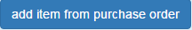 option, system displays the following page:

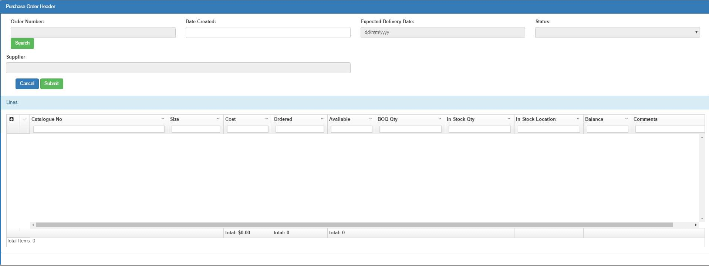

User needs to select Purchase Order Number and system populate the specific purchase order. User then select the specific item and enter values for Qty, In Stock Qty, In Stock Location and Comments and select ‘Submit’ button. The item added to the BOQ lines.

### Void a BOQ line

Provide ability to void a PENDING BOQ line. User can only void a ‘PENDING’ BOQ line. When user clicks on  option, system prompt for a comment and then void the line. After voiding, the line colour turns red



### 1.1.1. Delete BOQ Line

Provides ability for deleting manually created line. User can only delete a ‘PENDING’ MANUALLY created line. This option is not available for AUTO created line or for line with status other than ‘PENDING’

### Print Picking Slip

User can print picking slip by selecting 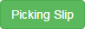 option. System will display picking slip as below:

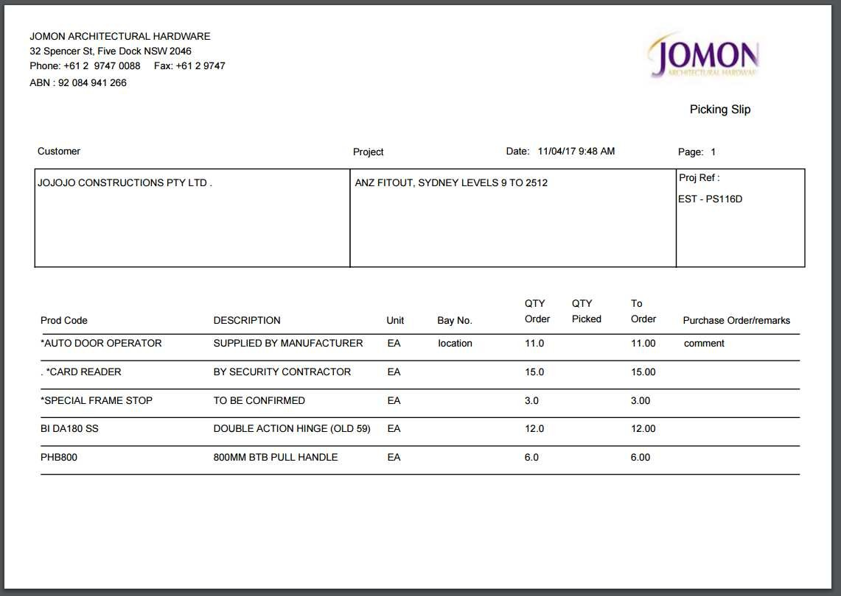

## Generate Purchase Order from BOQ

System provides this facility to create Purchase Order from one or multiple BOQs. select ‘BOQ List’ from menu



A list of recent imported BOQs appears with search options.

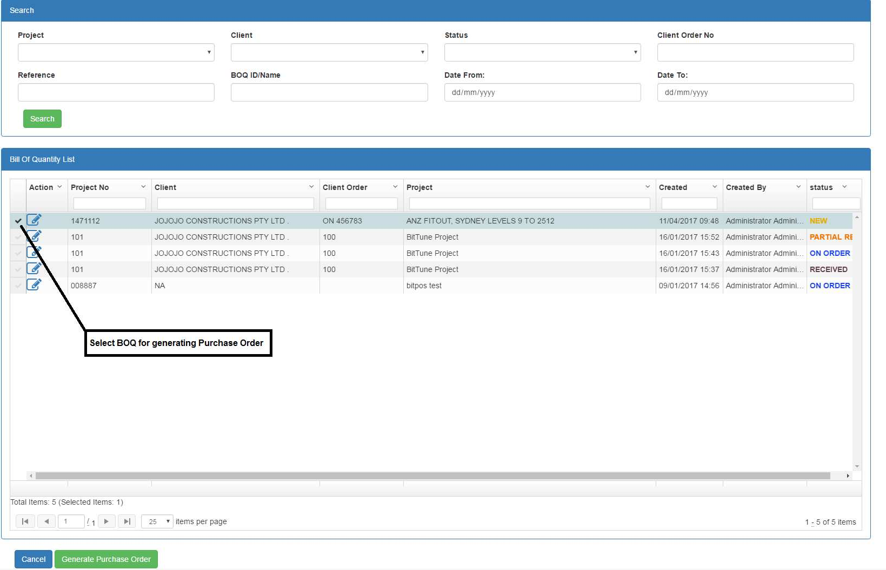

To generate Purchase Order form BOQ, select BOQs from the list by ticking the first column and then select 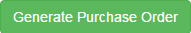 button. Please note that only BOQs with status are selectable from the list.

System generates Purchase Orders per each supplier found in selected BOQs. It includes all the products belong to that supplier found in selected BOQs and creates a Purchase Order for it and the displays created purchase orders as result. The status of selected BOQs in BOQ list turns to 

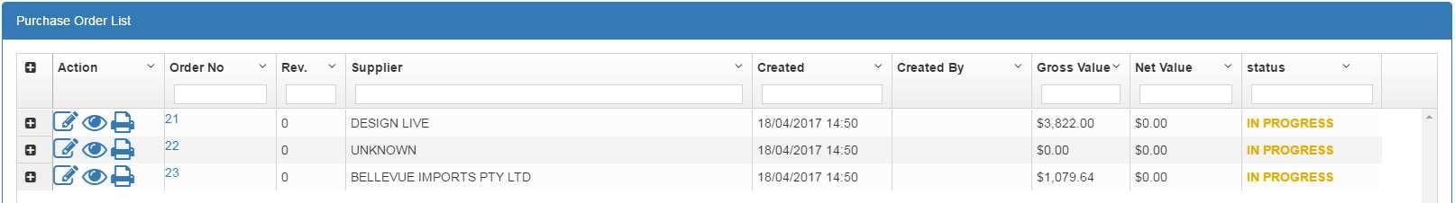

## Delete BOQ

Only BOQ with status  can be deleted from the system.

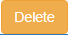For deleting a BOQ, select it from the BOQ List and then select button.

# Purchase Order

This function provides facilities for creating new purchase orders, editing existing purchase orders and searching for purchase orders.

## Search/view purchase orders

To view list of purchase orders or search for them, select ‘Purchase Order List’ item from menu

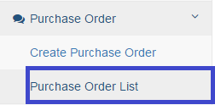

Purchase Order Search page appears populated with recent purchase orders.

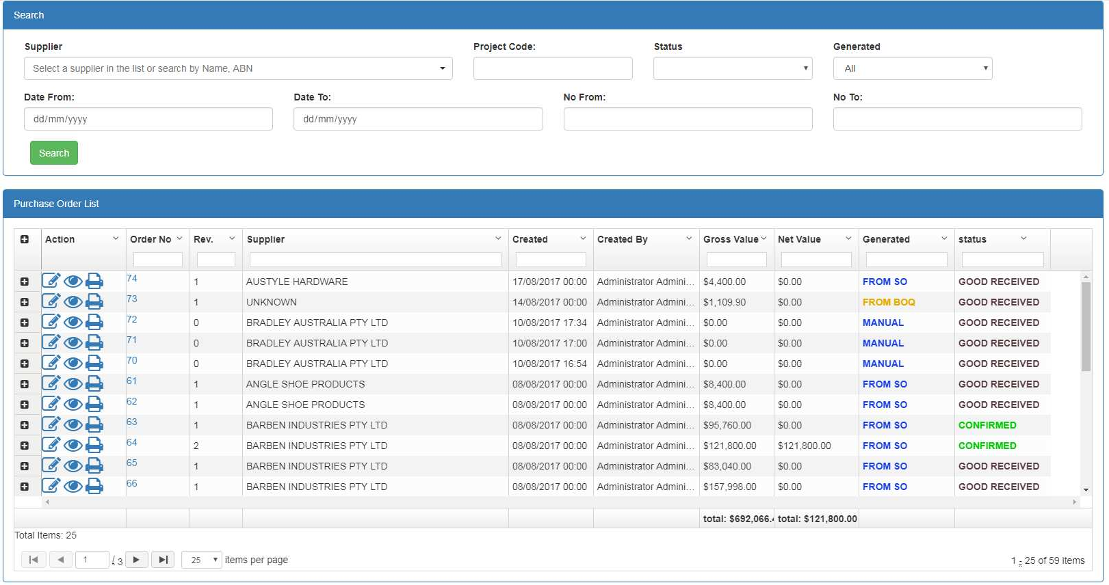

### Field Descriptions

|  |  |
| --- | --- |
| Field | Description |
| **Search Criteria** | |
| Supplier | Dropdown Box – Limits the display to those Purchase Orders that  belongs to the selected Supplier |
| Project Code | Entry Box - Limits the display to those Purchase Orders that belongs to  the selected Project Code |
| Status | Dropdown Box- status of purchase order:   * In Progress: purchase order is not confirmed * Confirm: purchase order is confirmed and sent to supplier * Cancelled: purchase order is cancelled * Partial REC: goods have been partially received * GOOD RECEIVED: goods have been fully received |
| Generated | Dropdown Box- creation method of purchase orders: |

|  |  |
| --- | --- |
|  | * Manual: Purchase order is created by user from ‘Create Purchase Order’ option * From BOQ: purchase order is generated from Bill Of Quantity * From SO: purchase order is generated from Sale Order |
| Date From | Date Box - Limits the display to those Purchase Orders that creation  date is after value entered for Date From |
| Date To | Date Box - Limits the display to those Purchase Orders that creation  date is before value entered for Date To |
| No From | Entry Box - Limits the display to those Purchase Orders that order no is  after value entered for No From |
| No To | Entry Box - Limits the display to those Purchase Orders that order no is  before value entered for No To |
| **Purchase Order List –** the empty box beneath each field is for filtering the list | |
| Order No | Display – Configured Order No associated with the Purchase Order |
| Rev. | Display- Configured Revision associated with the Purchase Order. After  each editing, revision increment by 1 |
| Supplier | Display- Configured Supplier associated with Purchase Order |
| Created | Display- Creation Date(Import date) associated with the Purchase  Order |
| Created By | Display-The user responsible for creating Purchase Order |
| Gross Value | The total value of Purchase Order before tax |
| Net Value | The total value of the Purchase Order after tax |
| Generated | Dropdown Box- creation method of purchase orders:   * Manual: Purchase order is created by user from ‘Create Purchase Order’ option * From BOQ: purchase order is generated from Bill Of Quantity * From SO: purchase order is generated from Sale Order |
| Status | : purchase order is created and saved as a draft but not submitted to the supplier  : purchase order is confirmed and submitted to the supplier  : Part of purchase order has been received.  : purchased order has been fully received. |
| Action | : open purchase order for edit  : open purchase order for view only  : print purchase order  : delete selected purchase order ( only applicable for purchase  order with  status |

To search for specific purchase orders, user needs to fill in the criteria boxes and select

button. the search result is based on pagination mechanism which means first page includes only the first 25th matched Purchase Order. For displaying the rest of the result, user can navigate through navigation buttons.

### Delete purchase order

User can delete purchase order by clicking on for that specific purchase order. Delete functionality is only applicable on Purchase Order with ‘OUTSTANDING’ status.

## Create/edit purchase order

To create a new purchase order, select ‘Create Purchase Order’ from menu

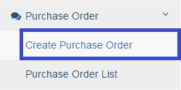

A blank purchase order page will display.

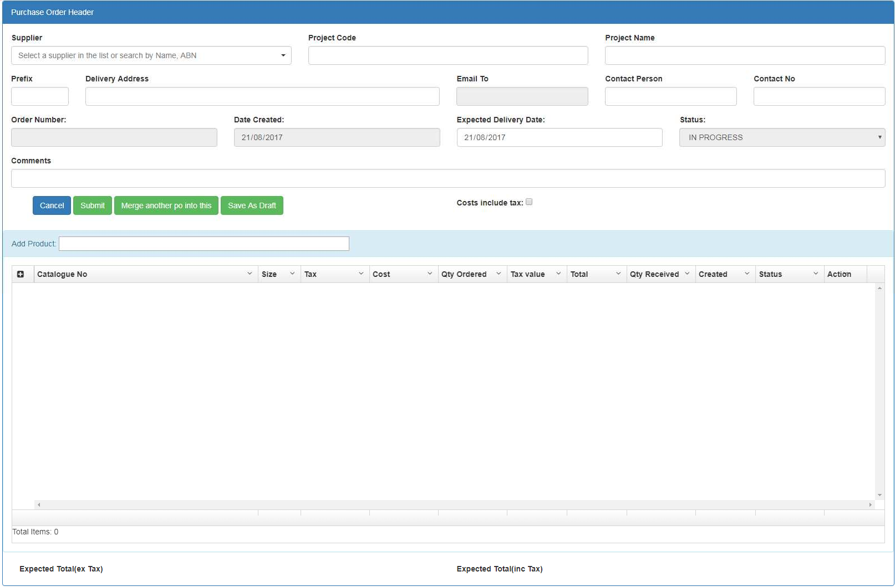

### Field Descriptions

|  |  |
| --- | --- |
| Field | Description |
| **Purchase Order Header** | |
| Supplier | Dropdown Box – Supplier whom products will be purchased from |
| Project Code | Entry Box – Project code which purchase order is belong to |
| Project Name | Entry Box – Project name which purchase order is belong to |
| Prefix | Entry Box – a prefix for categorizing purchase order. For example we  can enter the owner of purchase order or person who is responsible |

|  |  |
| --- | --- |
|  | for it |
| Delivery Address | Entry Box – Auto populate by system. If selected supplier had been  assigned a delivery address, then it will be appeared here |
| Email To | Display Box – Auto populate by system. If selected supplier had been  assigned an email, then it will be appeared here |
| Contact Person | Entry Box – Auto populate by system. If selected supplier had been assigned a contact person, then it will be appeared here |
| Contact No | Entry Box – Auto populate by system. If selected supplier had been  assigned a contact No, then it will be appeared here |
| Order Number | Display Box – order number is assigned to the Purchase order by the  system after creating the purchase order |
| Date Created | Date Box – the date purchase order was created. On creating a new purchase order it assigned to current date |
| Expected Delivery Date | Date Box – expected delivery date of the purchase order |
| Status | Display Box – the purchase order statrus:   * IN PROGRESS : purchase order is created and saved as a draft but not submitted to the supplier * CONFIREMED: purchase order is submitted and sent to the supplier * PARTIAL REC: goods are partially received * GOOD RECEIVED: all products are received |
| **Purchase Order Lines –** the empty box beneath each field is for filtering the list | |
| Catalogue No | Display – Supplier Catalogue No associated with the product |
| Size | Display- Product unit |
| Tax | Dropdown- tax applied on the item |
| Cost | Editable- Supplier cost associated to the product(inc. GST). User can  edit the default cost |
| Qty Ordered | Editable- Creation Date(Import date) associated with the Purchase  Order- user can edit the default qty |
| Value | Display-calculated value of line (Cost * Qty) |
| Qty Received | Display -Quantity received for this order line |
| Created | Display – Creation Method  :purchase line is generated from BOQ or SO : the purchase line is added manually by user |
| Status | : purchase order line is created and saved as a draft but not submitted to the supplier  : purchase order line is confirmed and submitted to the  supplier  : Part of purchase order line has been received.  : Whole quantity purchased for this line has been received. |
| Action | : Botton - delete the line – only available for purchase  line. |

### Add products to purchase order

User can add multiple products to purchase order by entering the ‘Catalogue No’ or ‘Part No’ in ‘Add Product’ box and then pushing the ‘Enter’ from keyboard.



If user push ‘Enter’ on empty box, all the products belong to the supplier will be displayed otherwise products containing the entered keyword will be displayed.

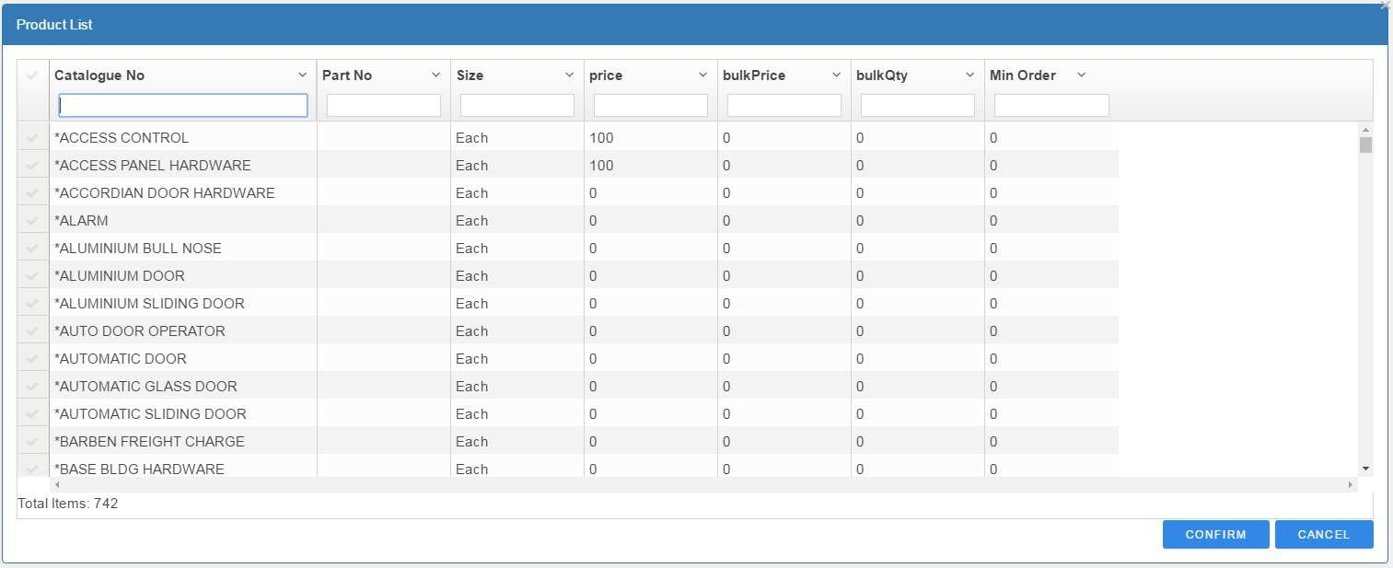

User can filter the list via filtering box beneath the columns and select the required products from the list. by confirming the selected products (clicking on the  button) the selected products will be added to the purchase order.

### Save purchase order as a draft

User can temporary save purchase order by clicking on the 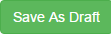 button. In this case the status of purchase order turns to . User can fetch the draft purchase order later and do further action on it

### Submit purchase order

User can submit the purchase order by clicking on the  button. Submitting of purchase order means sending it to the supplier. After submitting, the status of purchase order turns to 

# Good Received

This functionality enable user to register a good received note, search for received notes and edit received notes.

## Create Received Note

To create Received Note, select ‘Create Received Note’ from menu

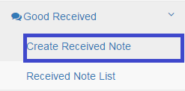

The ‘Received Note’ page appears as following:

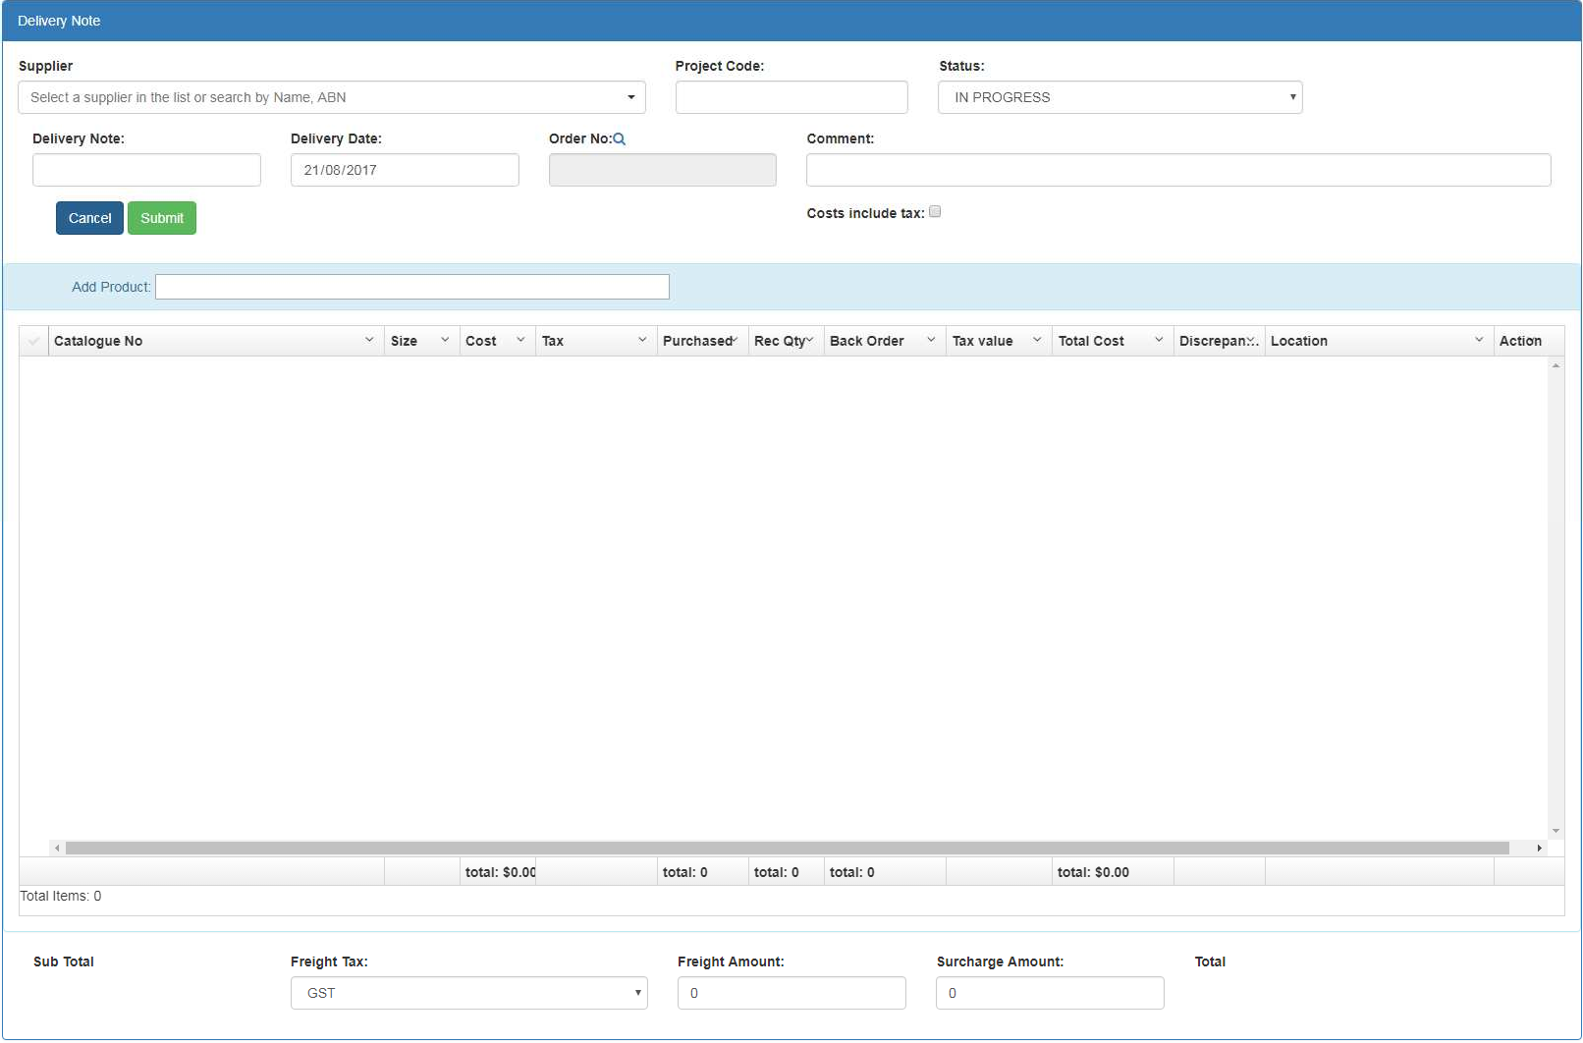

### Field Descriptions

|  |  |
| --- | --- |
| Field | Description |
| **Received Note Header** | |
| Supplier | Dropdown Box – Supplier whom goods are received |
| Project Code | Entry Box – Project code which this received note belongs to |
| Delivery Note | Entry Box – the number is assigned to the delivery note by the  supplier. |
| Delivery Date | Date Box – the date delivery note was delivered. The default is current date |

|  |  |
| --- | --- |
| Order No | Search Box – the purchase order no we receiving goods for |
| Status | Display Box – the Received Note status:  **IN PROGRESS** : Received note is created and saved but not applied to the system.(the stock level/related purchase order is not updated yet) **ON HOLD**: there has been a problem with receiving goods(not confirmed) and goods are in holding area for more investigation. It has not been applied to the system.  **COMPLETE**: the good received process is complete and applied to the system. In this case it updates the status of related purchase order to  ‘GOOD RECEIVED’ |
| Sub Total | Display only: displays the subtotal of received note lines |
| Freight Tax | Dropdown Box – if there is a freight cost associated with the Good  Received, the freight tax is entered here |
| Freight Amount | Entry Box - if there is a freight cost associated with the Good Received,  the amount entered here |
| Surcharge Amount | Entry Box- any surcharge amount associated with the Delivery Note |
| Total | Entry Box – total amount of the Delivery Note  Total = Sub Total + surcharge amount + freight amount + (Freight Tax * Freight Amount) |
| Comment | User comment on received note |
| **Received Note Lines –** the empty box beneath each field is for filtering the list | |
| Catalogue No | Display Only – Supplier Catalogue No. associated with the product |
| Case Size | Display Only- Product unit |
| Case Cost | Editable- Supplier cost associated to the product(inc. GST). User can  edit the default cost |
| Purchased | Display Only- quantity purchased for this product |
| Rec Qty | Entry Box – quantity received in this Received Note |
| Back Order | Display Only-Quantity yet to be received or purchase again(Purchased  – Rec Qty) |
| Total Cost | Total cost of this line/product received |
| Discrepancy | Display – indicate if there is a discrepancy between what was ordered  and what was received. If purchased is different from Rec Qty, the checkbox is ticked automatically. |
| Location | Location the goods are stored. For example Bay 1 |
| Action | : Botton - delete the line – only available for Received  Note line. |

**Register a delivery note**:

1. Select supplier from supplier list and enter the required information for other fields
2. Select Order No by clicking on the close to ‘Order No’. all the confirmed purchase orders submitted to the selected supplier appears.

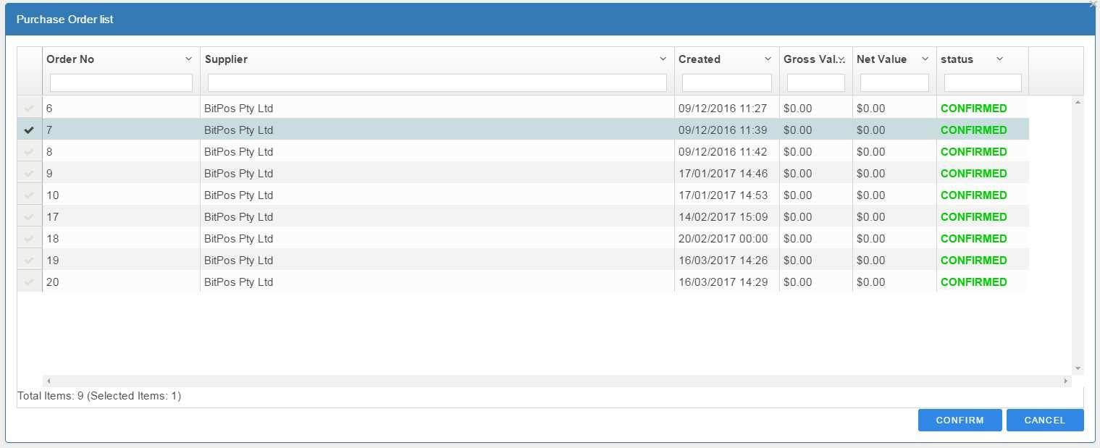

User can filter the purchase order and select the related one by clicking at the left hand side of the list and then select the  option

1. 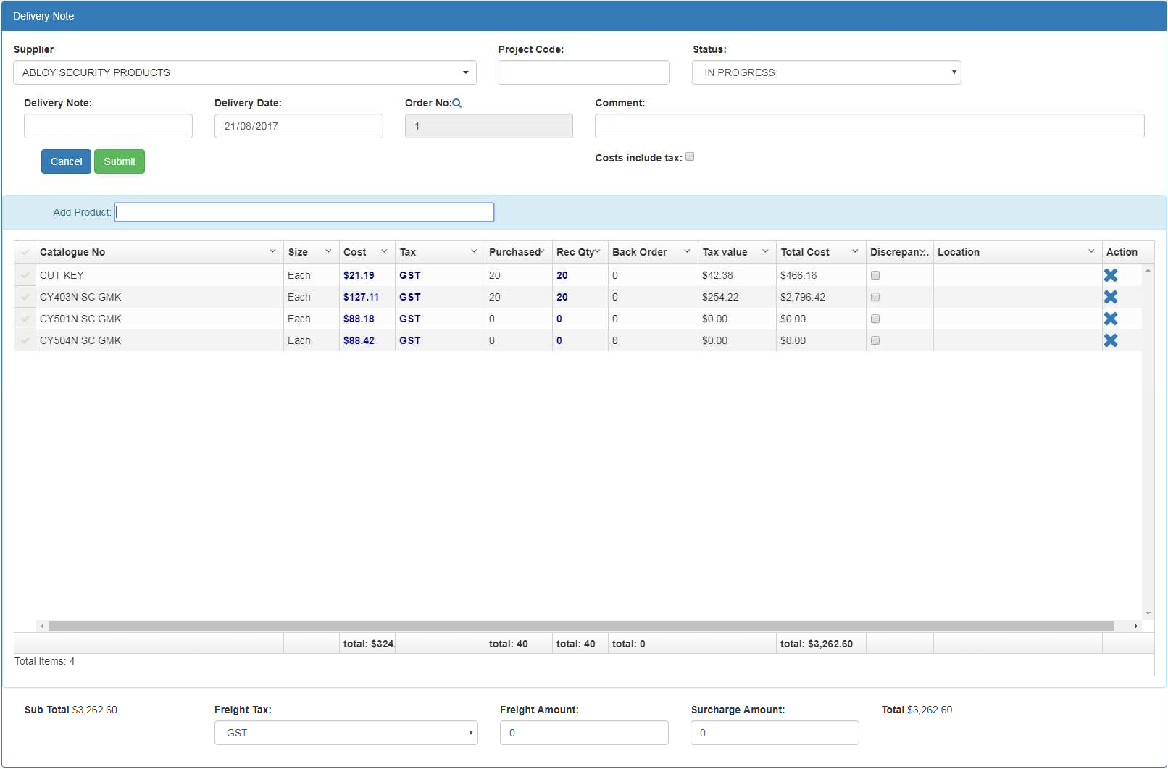All the products in the selected purchase order appear in the delivery note

The lines section is populated by selected purchase order lines. User can only change the ‘Rec Qty’ column or delete the items by clicking on the icon.

1. Sub total of all items is displayed in the left bottom corner of the page. User can enter the Freight Tax, Freight Amount and Surcharge amount if applicable. The Total amount is adjusted after entering the values for these fields.
2. User need to select 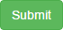 for saving the received note. System take different action depends on the status of the received note:
   1. For ‘IN PROGRESS’ and ‘ON HOLD’ status it just saves the record and not applying changes in the system
   2. For ‘COMPLETE’ it updates the status of related purchase order to ‘GOOD RECEIVED’ and stock quantities. If all products of purchase order is received and there is a Bill of Quantity linked to the purchase order, it also update the status of Bill Of Quantity to ‘PARTIAL REC’ OR ‘GOOD RECIVED’ depends on how much quantity is received.

After submitting the form, system will assign a GRN number to Received Note.

### 5.1.1 Add product from product list

User can add products from product list. this is useful when delivery note is not creating based on purchase order or user wants to receive extra items other than those are purchased.

For adding product user need to enter ‘Catalogue No’ or ‘Part No’ in ‘Add Product’ box and then push the ‘Enter’ key from keyboard.



If user push ‘Enter’ on empty box, all the products belong to the selected supplier will be displayed; otherwise products containing the entered keyword will be displayed.

## 5.2 View Received Note List/Search for received note

to search for a delivery note or edit existing one, user need to select ‘Received Note List’ from menu

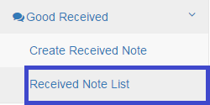

Received not list with search functionality appears:

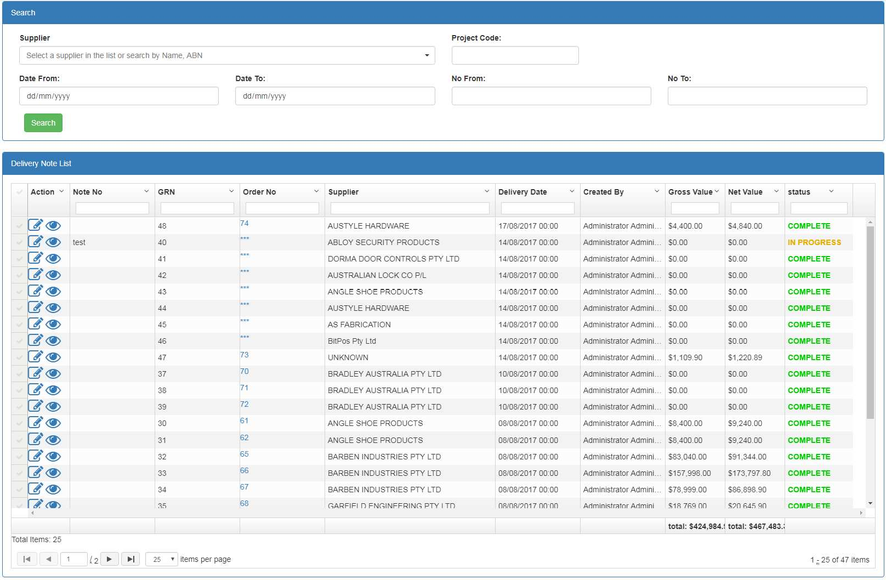

### Field Descriptions

|  |  |
| --- | --- |
| Field | Description |
| **Search Criteria** | |
| Supplier | Dropdown Box – Limits the display to those Received Notes that  belongs to the selected Supplier |
| Project Code | Entry Box – Project code |
| Date From | Date Box - Limits the display to those Received Notes that creation  date is after value entered for Date From |
| Date To | Date Box - Limits the display to those Received Notes that creation  date is before value entered for Date To |
| No From | Entry Box - Limits the display to those Received Notes that GRN  number is after value entered for No From |
| No To | Entry Box - Limits the display to those Received Notes that GRN  number is before value entered for No To |
| **Received Note List –** the empty box beneath each field is for filtering the list | |
| Note No | Display – Configured Note No associated with the Received Note |
| GRN | Display- Configured GRN associated with the Received Note. GRN is an  internal number assigned to the Received Note for internal reference while Note No is assigned by supplier |
| Supplier | Display- Configured Supplier associated with Received Note |
| Delivery Date | Display- Delivery Date associated with the Received Note |
| Created By | Display-The user responsible for registering Received Note |
| Gross Value | The total value of received note before tax |
| Net Value | The total value of the received note after tax |

|  |  |
| --- | --- |
| Status | : received note is created and saved but not applied to the  system.  : there has been a problem with receiving goods(not confirmed) and goods are in holding area for more investigation. It has not been applied to the system  : the good received process is complete and applied to the system. In this case it updates the status of related purchase order to  ‘GOOD RECEIVED’ |
| Action | : open received not for edit- the received note with  status is not edittable( the submit botton on edit page is disabled)  : open received note for view only |

The result is displayed on pagination basis. The first page includes 25th matched records. User can navigate on other pages by selecting the navigation buttons



* 1. **Edit** Received Note

For editing a received note, user need to go to the ‘Received Note List’, search for received note and then select button for editing or for viewing the delivery note. the received note with  status is not edittable( the submit botton on edit page is disabled)

# Sales Transactions

System supports the following sales transactions:

* Quote : provide facility for registering a customer quote
* Sale Order : provide facility for registering sale order.
* Invoice : provide facility for registering an Invoice. Multiple invoices may generate from Sale Order.

Each sale order might yield to one or more Invoices.

# Please note: If sale order is created for a customer, all invoices must be created from that sale order

## Quote

select ‘Quote’ from menu.

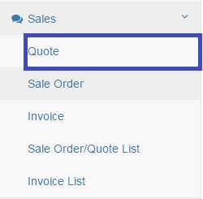

The Quote page appears:

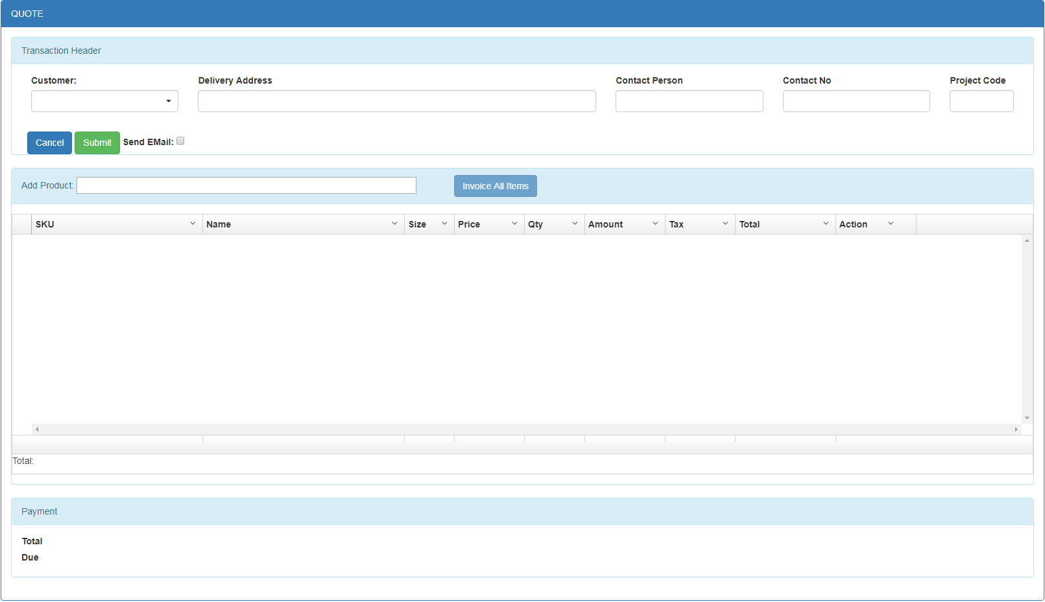

Field Description

|  |  |
| --- | --- |
| Field | Description |
| **Quote Header** | |

|  |  |
| --- | --- |
| Customer | Dropdown Box – Customer who asked for a quote |
| Delivery Address | Entry Box – Customer delivery address. Auto populated by system  from customer record |
| Contact Person | Entry Box – Contact person from customer side |
| Contact No | Entry Box – the contact number associated with contact person |
| Project Code | Entry Box – if quote is for specific project, project code is entered here |
| Total | The total amount of quote |
| Due | Due amount of quote |
| **Products Lines –** the empty box beneath each field is for filtering the list | |
| SKU | Display Only – product sku |
| Name | Display Only- Product name |
| Size | Display Only- Product unit |
| Price | Editable box – product price |
| Qty | Entry Box – quantity requested |
| Amount | Display Only- line value ( Price * Quantity) |
| Tax | Display Only – tax amount applies on product. This is calculated based  on the number of taxes assigned to the product and the tax values from product page |
| Total | Display Only – Total amount(net value include tax) need to be paid for this line |
| Action | : Botton - delete the line |

**For registering a new Quote:**

1. User need to enter the required information into entry fields.
2. To add products, user need to enter the SKU or product name in

 box and push the ‘Enter’ key.

1. By pushing the ‘Enter’ key on blank box, all the products will be displayed; otherwise the product containing the enter keyword will be appears.

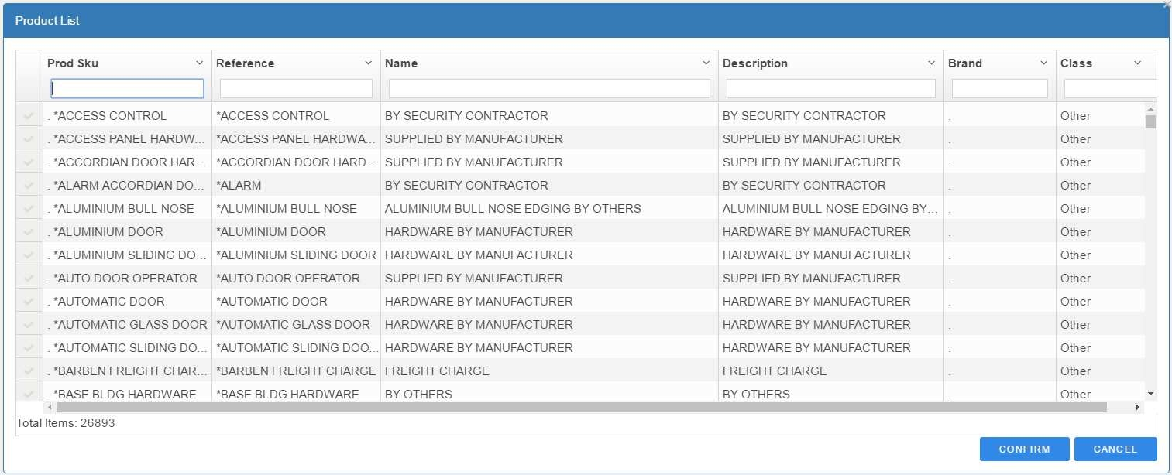

User can filter required products by entering in Entry Boxes beneath each field.

1. User need to select products by clicking on 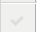 area on left hand side of product list. by selecting each product, Filtering boxes clears and user can filter it again and select another products.
2. After selecting all required products, user can confirm selection by choosing  button or cancel their selection by choosing  button.
3. In case of confirming the products, all of them is added to the Products section of the quote and total value is displayed to the user

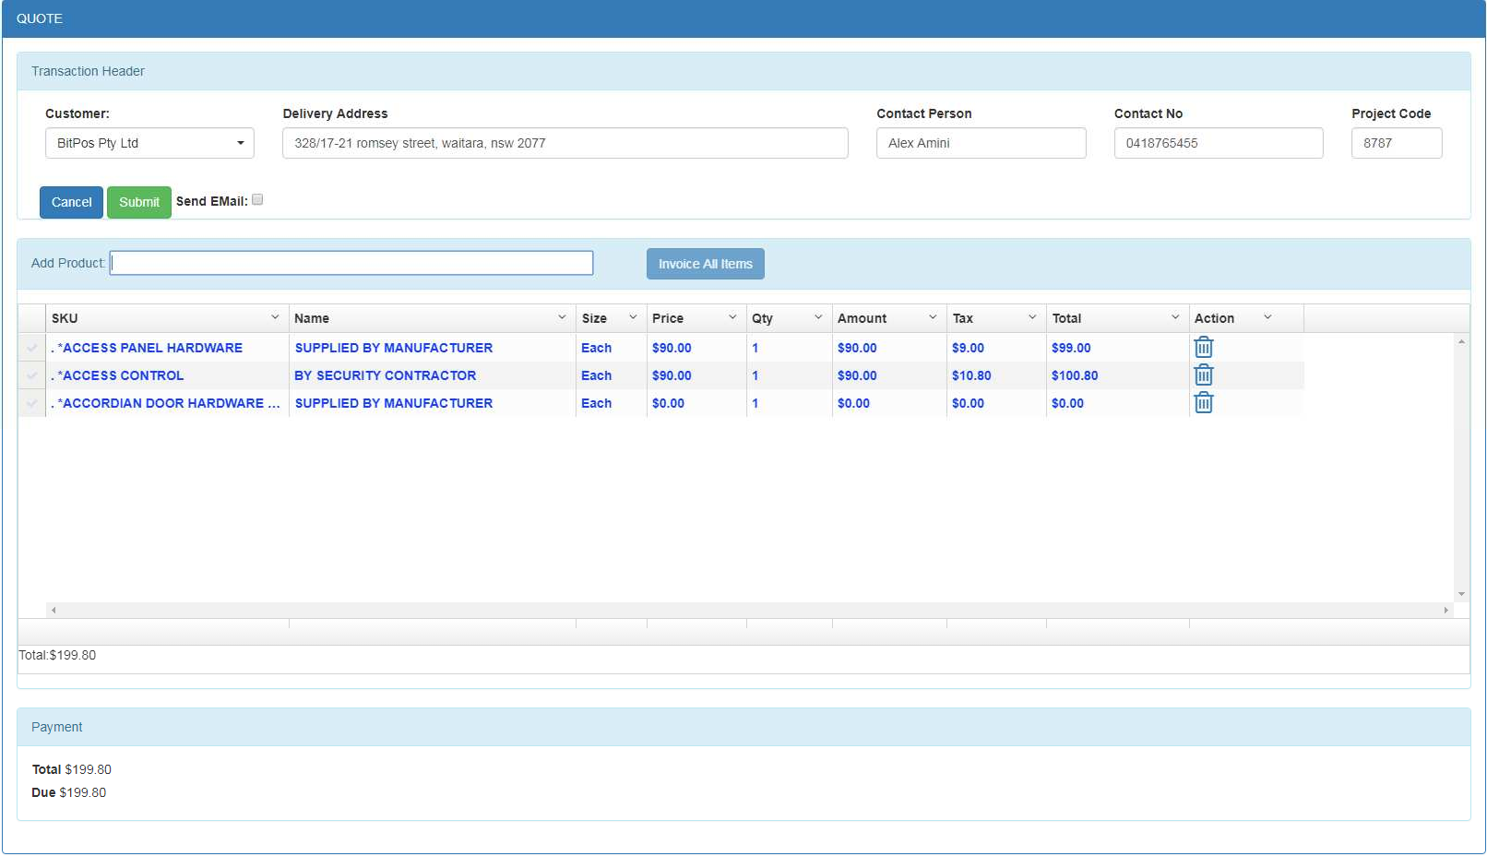

1. User can add more products to the quote by repeating the same process 8- If quote need to be send to the customer by email, user can check

section and enter the email address. if email had entered for customer in customer page, the email address is populate by the default email address.

1. User can save the Quote by click on  button. The quote will also be sent to the nominated email address.

## Sale Order

to register a Sale Order, user need to select ‘Sale Order’ from menu.

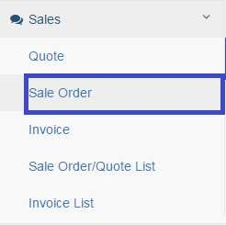

The Sale Order page appears:

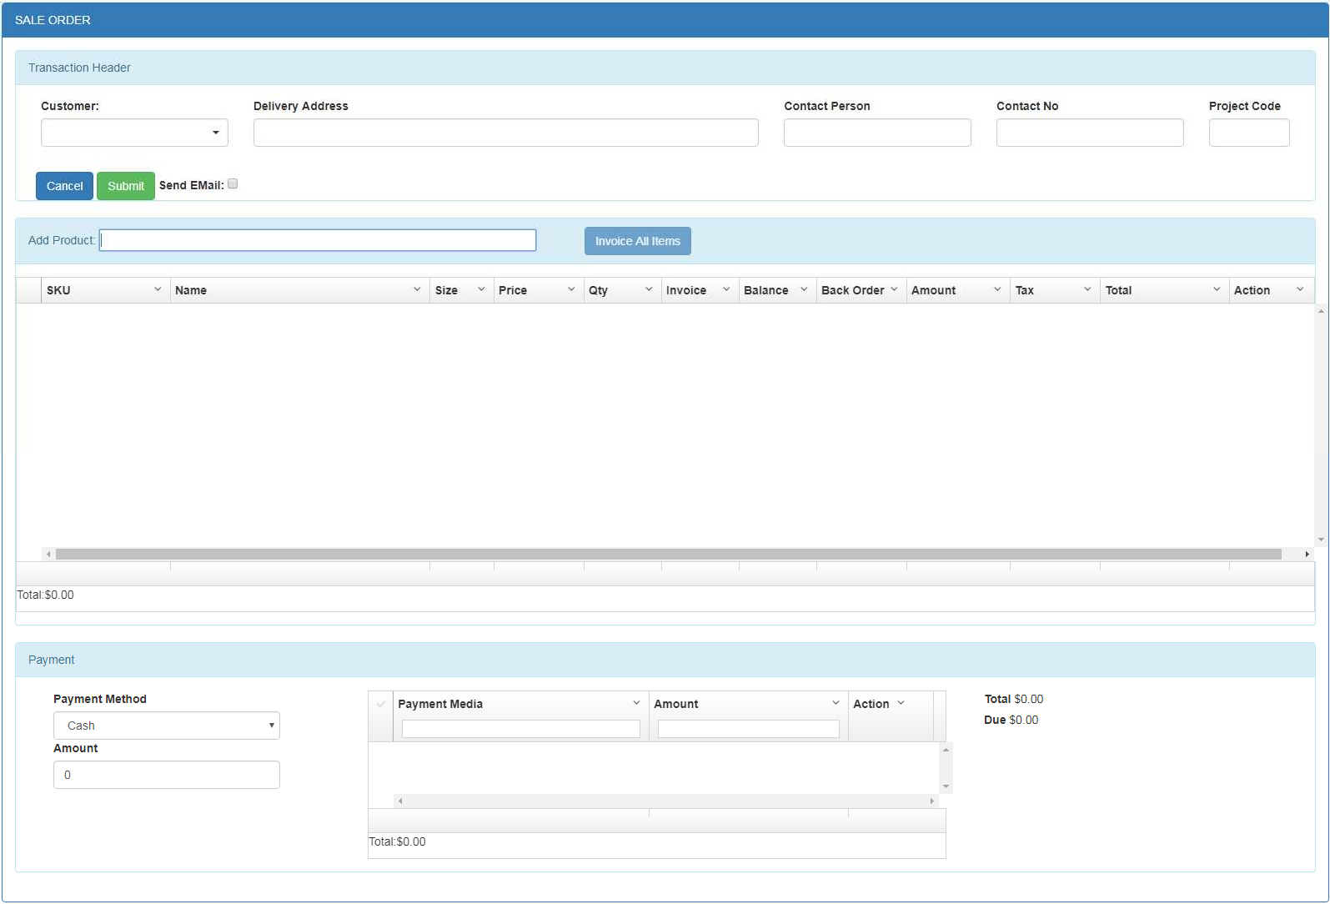

Field Description

|  |  |
| --- | --- |
| Field | Description |
| **Sale Order Header** | |
| Customer | Dropdown Box – Customer who asked for a Sale Order |
| Delivery Address | Entry Box – Customer delivery address. Auto populated by system  from customer record |
| Contact Person | Entry Box – Contact person from customer side |
| Contact No | Entry Box – the contact number associated with contact person |
| Project Code | Entry Box – Project which this sale order belongs to |
| **Products Lines –** the empty box beneath each field is for filtering the list | |
| SKU | Display Only – product sku |
| Name | Display Only- Product name |
| Size | Display Only- Product unit |
| Price | Editable box – product price |
| Qty | Entry Box – quantity requested in sale order |
| Invoice | Entry Box – Quantity invoiced this time –  Note : multiple invoice can be created from sale order. We can invoice some part of the sale order on creating sale order. In this case system will create two transaction, one for sale order and one for invoice |
| Balance | Display only – the balance need to be delivered of this item to the |

|  |  |
| --- | --- |
|  | customer later( Qty – Invoice) |
| Back Order | Entry Box- the quantity that is not available in stock and need to be ordered from main supplier. The default value calculated as below but user can change it:  Back Order = QTY – (Quantity in stock for that item)  When creating Purchase Order from Sale Order, the ‘Back Order’ value is used for quantity will be purchased |
| Amount | Display Only- line value ( Price * Qty for sale order and Price * Invoice  for invoice) |
| Tax | Display Only – tax amount applies on product. This is calculated based on the number of taxes assigned to the product and the tax values  from product page |
| Total | Display Only – Total amount(net value include tax) need to be paid for this line |
| Action | : Botton - delete the line |
| Transaction Footer | |
| Payment Method | Dropdown box: Payment method for example: Cash, Cheque, Master card …. |
| Amount | Entry Box – Amount is going to be paid by selected payment method |
|  | To add payment amount to the payment list. user can pay with multiple payment method. For example some portion with cash, some portion with card or cheque and some portion from Account. For each payment, user need to select Method and amount and then add it to  the payment list by clicking on the botton or pushing the ‘Enter’ key. After adding to the payment list, the Due amount will be modified  according to the payment made. |
| Total | The total amount of Sale Order |
| Due | Due amount of Sale Order |

For registering a new Sale Order:

1. User need to enter the required information into entry fields. 11- To add products, user need to enter the SKU or product name in

 box and push the ‘Enter’ key.

1. By pushing the ‘Enter’ key on blank box, all the products will be displayed; otherwise the product containing the enter keyword will be appears.



User can filter required products by entering in Entry Boxes beneath each field.

1. User need to select products by clicking on  area on the left hand side of product list. by selecting each product, Filtering boxes clears and user can filter it again and select another products.
2. After selecting all required products, user can confirm selection by choosing  button or cancel their selection by choosing  button.
3. In case of confirming the products, all of them is added to the Products section of the sale order. Total and Due value is adjusted accordingly

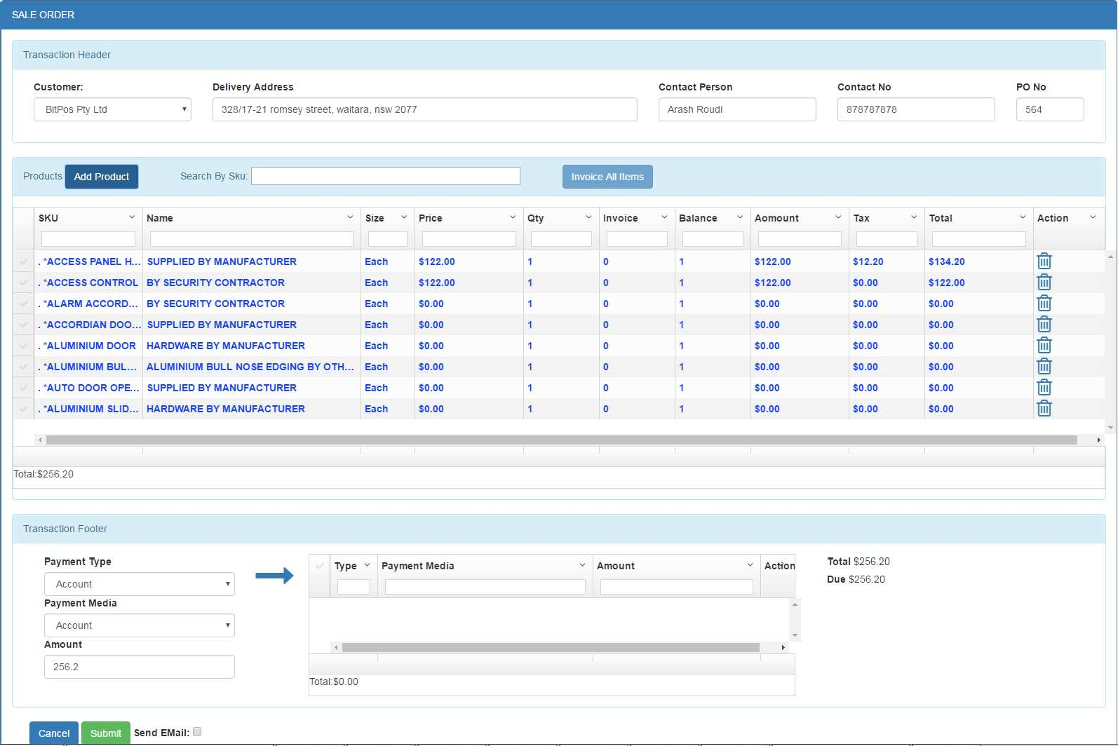

1. User can add more products to the Sale Order by repeating the same process or can delete a product by selecting 
2. User can do multiple payments for sale order. For doing a payment, select Payment Method and enter amount that need to be paid and then select button or push the ‘Enter’ key.

The payment is added to the payment list and Due amount is changed accordingly. User can repeat this step for doing multiple payment with different payment media

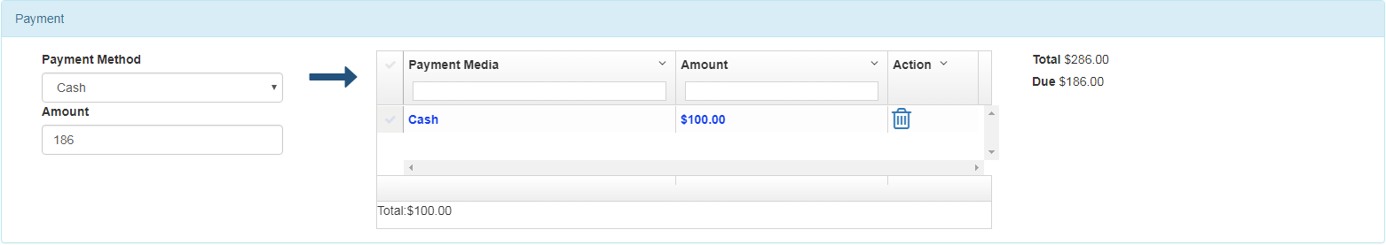

If needed, user can delete a payment from payment list by clicking on button. The Due amount will change accordingly

1. If sale order needs to be send to the customer by email, user can check

section and enter the email address.

The email address is populated by the default email address, If email is assigned to the customer.

User can save the Sale Order by click on  button. By submitting sale order, a new sale order number is assigned to it and displayed on the system. the Sale Order will also be sent to the nominated email address.

### Invoicing part of sale order

Sale Order page has two modes: Sale Order and Invoice. In each mode the values of ‘Amount’ and ‘Total’ columns of each item in ‘product list’ are calculated as following:

* + - * Sale Order Mode: in this mode for each product the Qty ordered (Qty) is used in calculation
        + Amount = Qty * Price
        + Total = Amount + Tax
      * Invoice Mode: in this mode for each product the qty invoiced (invoice) is used in calculation
        + Amount = Invoice * Price
        + Total = Amount + Tax
        + Balance = Qty - Invoice

### Invoice Mode:

User can invoice part of sale order at the same time of creating sale order. If user select  checkbox for a product(at the left side of the product list) or enter a value in Invoice field, page mode changes to the invoice mode and  button changes to 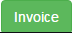 button. In this mode all the figures re-calculate according to value entered for ‘Invoice’ column in product list. if user select  button, system will generate two transactions one for invoice and one for sale order and link them together.

### Sale Order Mode:

By clearing the  check box or resetting the values of ‘Invoice’ column for all products, the page mode change to Sale Order and  button change to .

## 6.3 Invoice

### This section discuss how to create standalone Invoice(Invoices not based on Sale Order). For creating invoice from sale order please refer to previous section.

To register an invoice, user need to select ‘Invoice’ from menu.

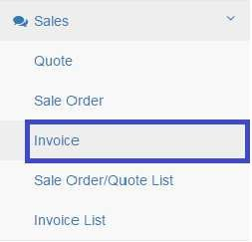

The invoice page appears:

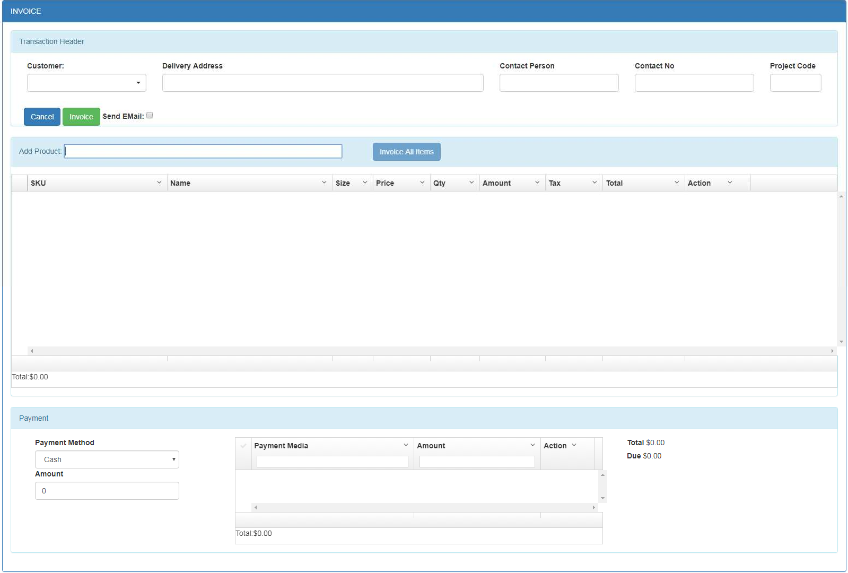

Field Description

|  |  |
| --- | --- |
| Field | Description |
| **Invoice Header** | |
| Customer | Dropdown Box – Customer who asked for an Invoice |
| Delivery Address | Entry Box – Customer delivery address. Auto populated by system  from customer record |
| Contact Person | Entry Box – Contact person from customer side |
| Contact No | Entry Box – the contact number associated with contact person |
| Project Code | Entry Box – Project code this invoice belongs to |
| **Products Lines –** the empty box beneath each field is for filtering the list | |
| SKU | Display Only – product sku |
| Name | Display Only- Product name |
| Size | Display Only- Product unit |
| Price | Editable box – product price |
| Qty | Entry Box – quantity requested in Invoice |
| Amount | Display Only- line value (Price * Invoice) |
| Tax | Display Only – tax amount applies on product. This is calculated based on the number of taxes assigned to the product and the tax values  from product page |
| Total | Display Only – Total amount(net value include tax) need to be paid for this line |
| Action | : Botton - delete the line |
| Transaction Footer | |
| Payment Method | Dropdown box: Payment method for example:  Cash, Cheque, Master card …. |
| Amount | Entry Box – Amount is going to be paid by selected payment method |
|  | To add payment amount to the payment list. user can pay with multiple payment method. For example some portion with cash, some portion with card or cheque and some portion from Account. For each payment, user need to select Method and amount and then add it to  the payment list by clicking on the botton or pushing the ‘Enter’ key. After adding to the payment list, the Due amount will be modified  according to the payment made. |
| Total | The total amount of Invoice |
| Due | Due amount of Invoice |

For registering a new Invoice:

1. User need to enter the required information into entry fields.
2. To add products, user needs to enter the SKU or product name in

 box and push the ‘Enter’ key.

1. By pushing the ‘Enter’ key on blank box, all the products will be displayed; otherwise the product containing the enter keyword will be appears.



User can filter required products by entering in Entry Boxes beneath each field.

1. User need to select products by clicking on  area on the left hand side of product list. by selecting each product, Filtering boxes clears and user can filter it again and select another products.
2. After selecting all required products, user can confirm selection by choosing  button or cancel their selection by choosing  button.
3. In case of confirming the products, all of them are added to the Products section of the invoice. Total and Due value is adjusted accordingly

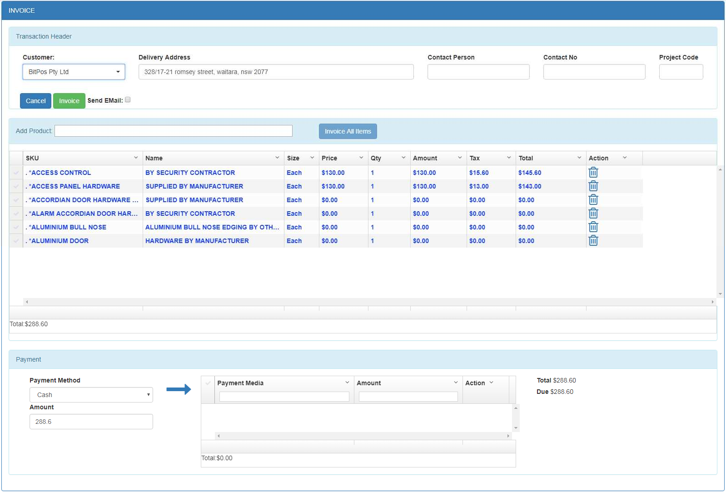

1. User can add more products to the Invoice by repeating the same process or can delete a product by selecting 
2. User can do multiple payments for invoice. For doing a payment, select Payment Method

and enter amount that need to be paid and then select button or push the ‘Enter’ key. The payment is added to the payment list and Due amount is changed accordingly. User can repeat this step for doing multiple payment with different payment media



1. If needed, user can delete a payment from payment list by clicking on button. The Due amount will change accordingly
2. If Invoice needs to be send to the customer by email, user can check

section and enter the email address. If email had entered for customer in customer page, the email address is populate by the default email address.

User can save the Invoice by click on  button. By submitting invoice, a new invoice number is assigned to it and displayed on the system. the invoice will also be sent to the nominated email address.

# Search Sale Order/Quote List

User can search for Sale Orders / Quotes and access to the detail by using this feature. Select ‘Sale Order/Quote List’ from menu

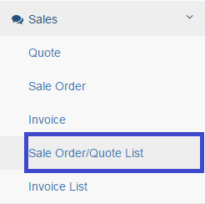

The search page displays as following:

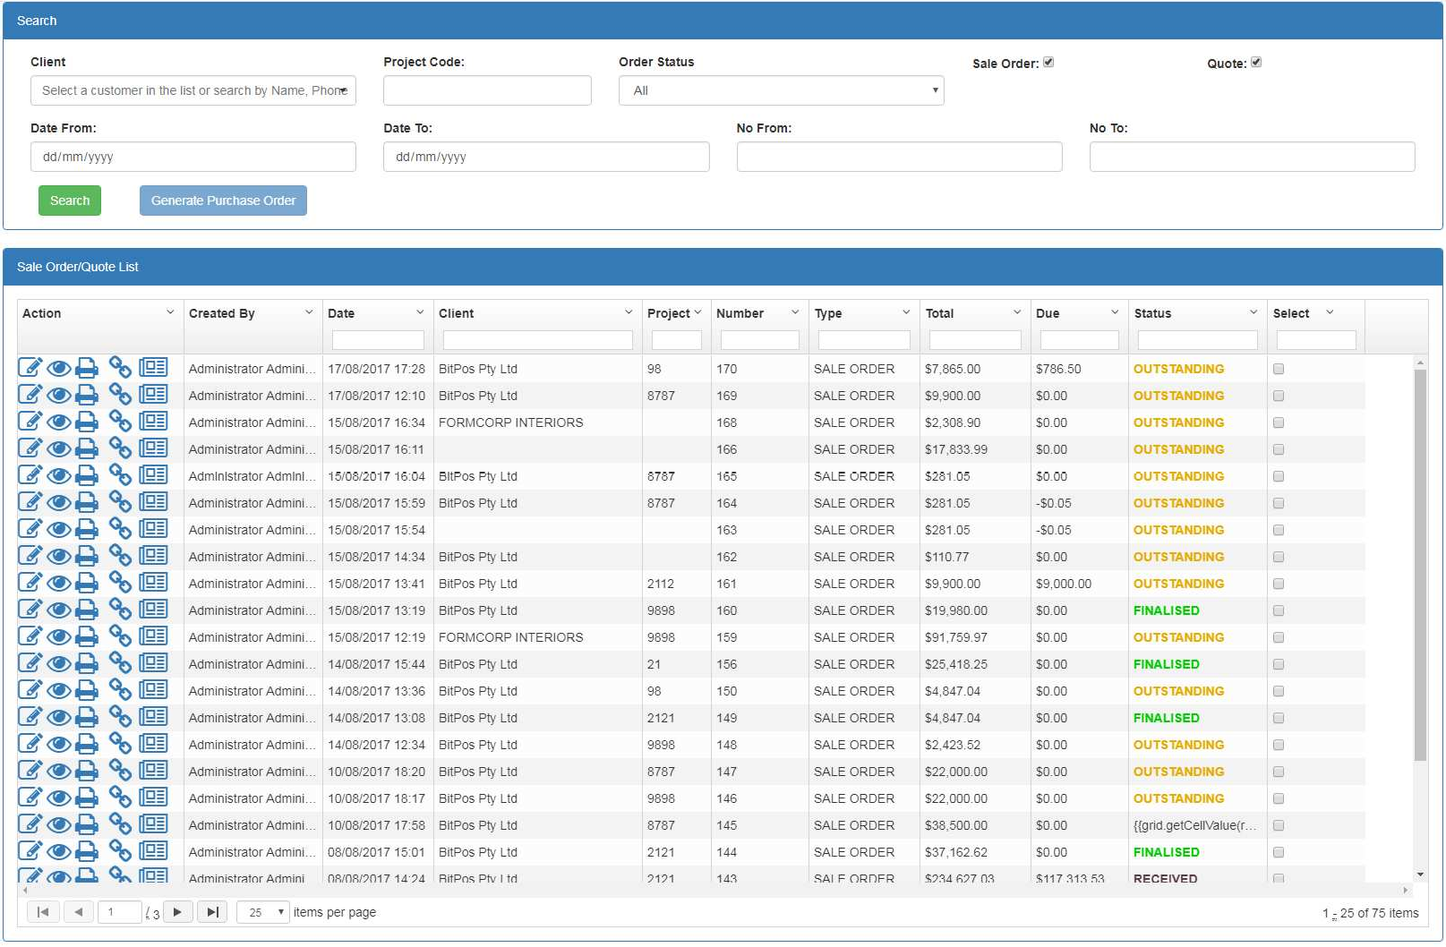

### Field Description

|  |  |
| --- | --- |
| Field | Description |
| **Search Criteria** | |
| Client | Dropdown Box – Limits the display to those Sale Orders/ Quotes that  belongs to the selected Client |
| Project Code | Entry Box – Project Code |
| Order Status | Dropdown Box –sale order status   * Outstanding: some items of sale order had not been invoiced. * ON ORDER: purchase order had been generated from Sale Order but good had not been received yet * PARTIAL REC: some items had been received |

|  |  |
| --- | --- |
|  | * RECEIVED: all items had been received * FINALISED: all items had been invoiced to the customer. |
| Sale Order | Check Box – if checkbox is ticked, the matched sale orders will be  included in search result |
| Quote | Check Box – if checkbox is ticked, the matched quotes will be included  in search result |
| Date From | Date Box - Limits the display to those records that creation date is after  value entered for Date From |
| Date To | Date Box - Limits the display to those records that creation date is  before value entered for Date To |
| No From | Entry Box - Limits the display to those Sale Orders/Quotes that no is  after value entered for No From |
| No To | Entry Box - Limits the display to those Sale Orders/Quotes that no is  before value entered for No To |
| **Sale Order/Quote List –** the empty box beneath each field is for filtering the list | |
| Created By | Display-The user responsible for creating Sale Order/Quote |
| Create Date | Display- Creation Date associated with the Sale Order/ Quote |
| Client | Display- Client associated with Sale Order/ Quote |
| Number | Display – Sale Order/ Quote Number |
| State | State is only applicable to the sale order  :Sale Order has not been fully paid.  : sale order has been fully paid. |
| Type | Type of the record. Sale Order or Quote |
| Total | Total value of Sale Order/ Quote |
| Due | Due amount of Sale Order/ Quote |
| Status | Display- the status of sale order:   * Outstanding: some items of sale order had not been invoiced. * ON ORDER: purchase order had been generated from Sale Order but good had not been received yet * PARTIAL REC: some items had been received * RECEIVED: all items had been received * FINALISED: all items had been invoiced to the customer. |
| Select | Check box: select this item for further actions for example generating  purchase order |
| Action | : open sale order/quote for edit  : open sale order/quote for view only  : print sale order  : delete Quote (applicable for quotes only)  : view linked purchase orders(purchase orders created from this sale order)  : invoices/refunds(all invoices/refunds created from this sale  order |

User needs to enter the search criteria and then select the search option. The result will be displayed in the result list.

The result is displayed on pagination basis. The first page includes 25th matched records. User can navigate on other pages by selecting the navigation buttons



## Edit Sale Order/Quote

User can edit Sale Order until it is in ‘FINALISED’ state. By selecting edit function user can do the following on the Sale Order:

1- Add products to the sale order 2- Remove products

1. Change the product price
2. Add payment to the sale order

For editing a Sale Order/ Quote, user need to select it from the Sale Order/ Quote list(please refer to the previous section) and then select  icon from the Action columns. The Sale Order/Quote page populated with the selected record appears.

## Create Purchase Order from Sale Order

User can create purchase order from those sale orders with ‘OUTSTANDING’ status.

As mentioned in ‘Sale Order’ section, every item in sale order is assigned ‘Back Order’ value. This value is default to the difference of Quantity ordered by customer and Quantity available in stock for that item. The ‘Back Order’ value for each item is used in this section for quantity that need to be purchased from main supplier.

For generating Purchase Order from Sale Order:

1- select those specific sale orders from ‘Sale Order’ list.

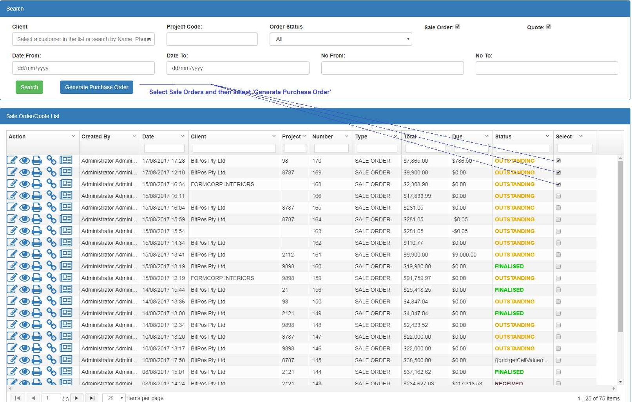

User also can search for specific sale orders, select them and then again search for another sale orders and select from those result as well.

3- After selecting all required sales orders, user need to select 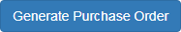 button. 4- A confirmation page including those selected sale orders appears and ask user for

confirmation

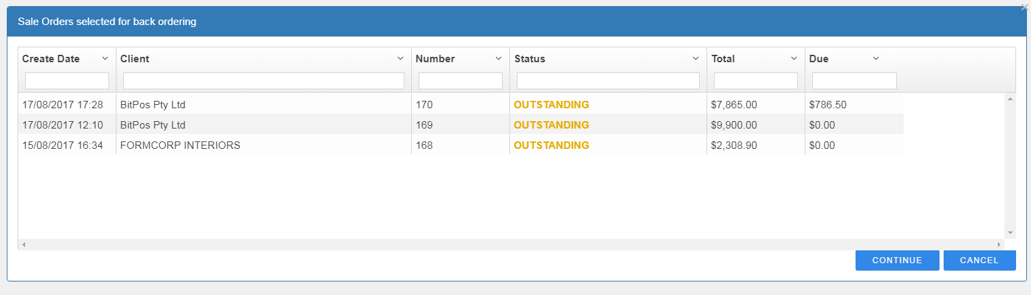

1. User can select  for generating Purchase Orders from those selected sales orders.

User also can select . By selecting ‘Cancel’ user returns to the previous page.

1. System will generate Purchase Orders from selected Sales Orders and display the result to the user:

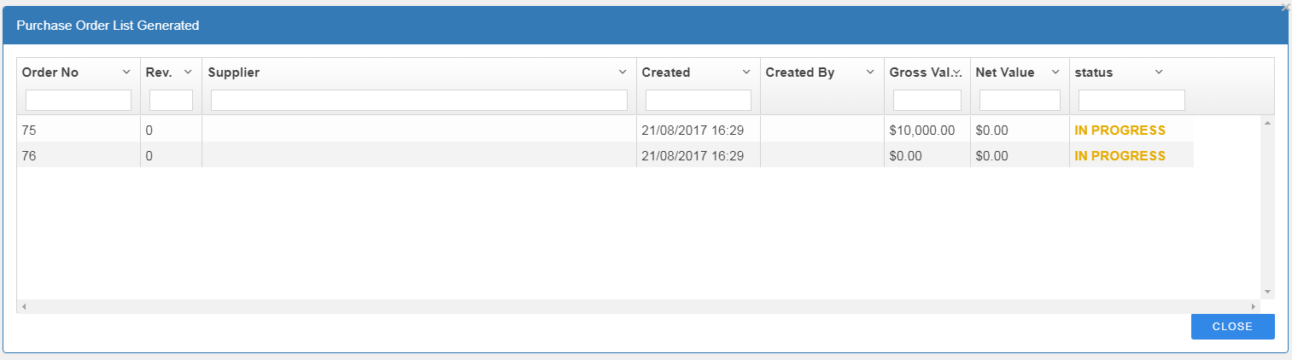

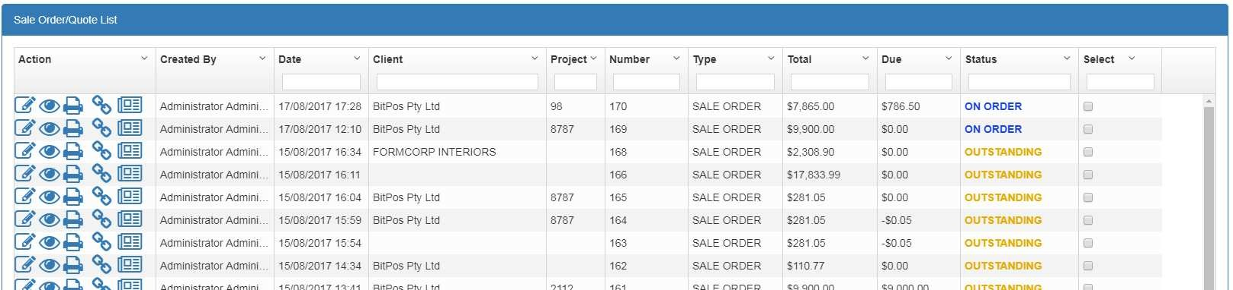After generating Purchase Order from Sale Order, Sale Order status automatically changes to

From this point on, the Sale Order status is controlled by purchase order status and automatically get updated by system as following. This helps user to track sales order status:

* If some portion of purchased items received and user register the received note(good received), the status of sale order changes to ‘PARTIAL REC’(which means items had been partially received.
* If all purchased items of sale order are received, the sale order status changes to ‘RECEIVED’

## View linked purchase orders

User can view all linked purchase orders have been created for this sale order by clicking on  option from sale order list.

System will display linked purchase orders as below:

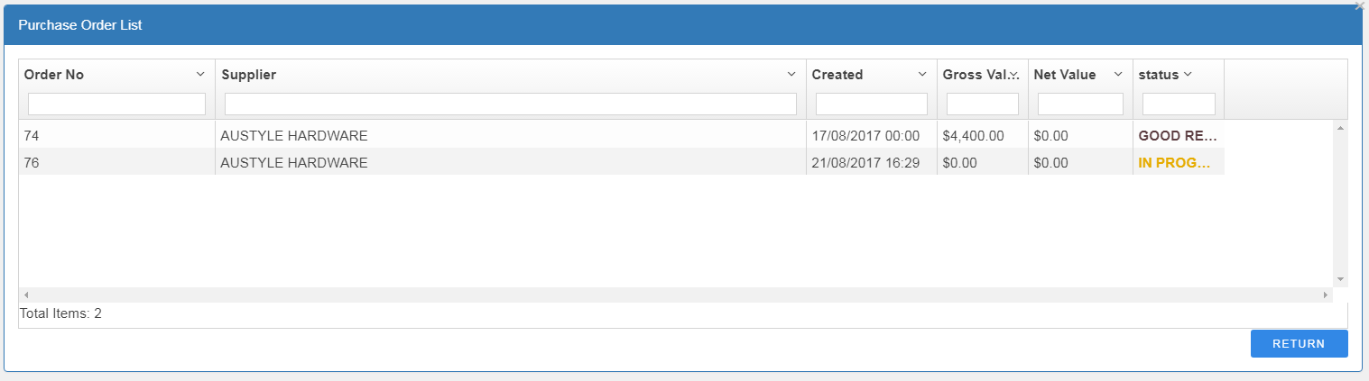

## View Invoices/Refunds of purchase order

User can view all Invoices/Refunds have been created based on this sale order by clicking  option from sale order list. system display linked invoices/refunds as below:

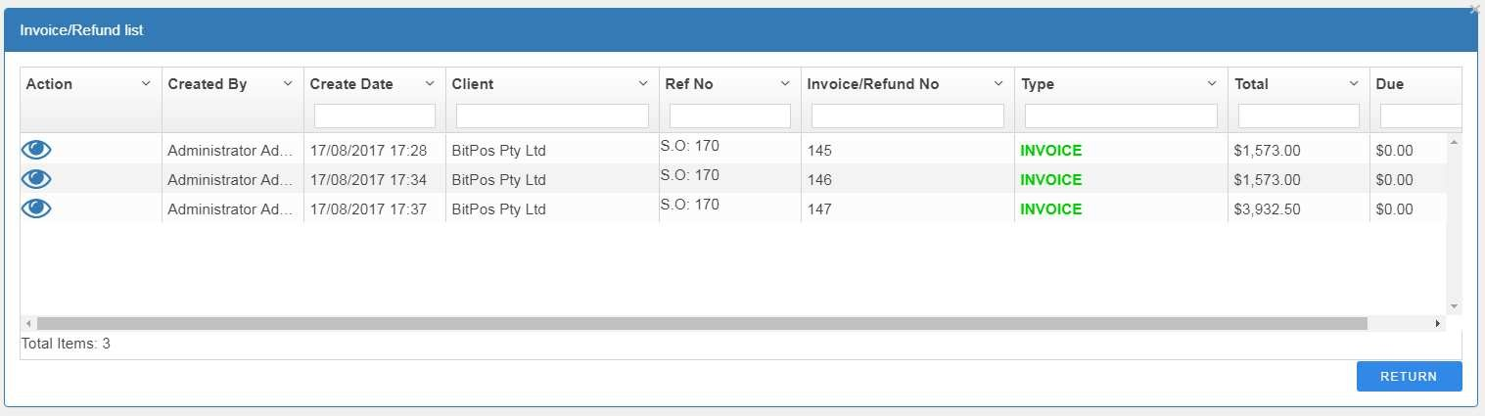

# Search and view Invoice/Refund List

User can search for Invoices/Refunds and access to the detail by using this feature. Select ‘Invoice List’ from menu

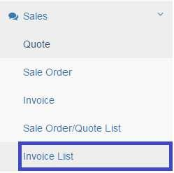

The search page displays as following:

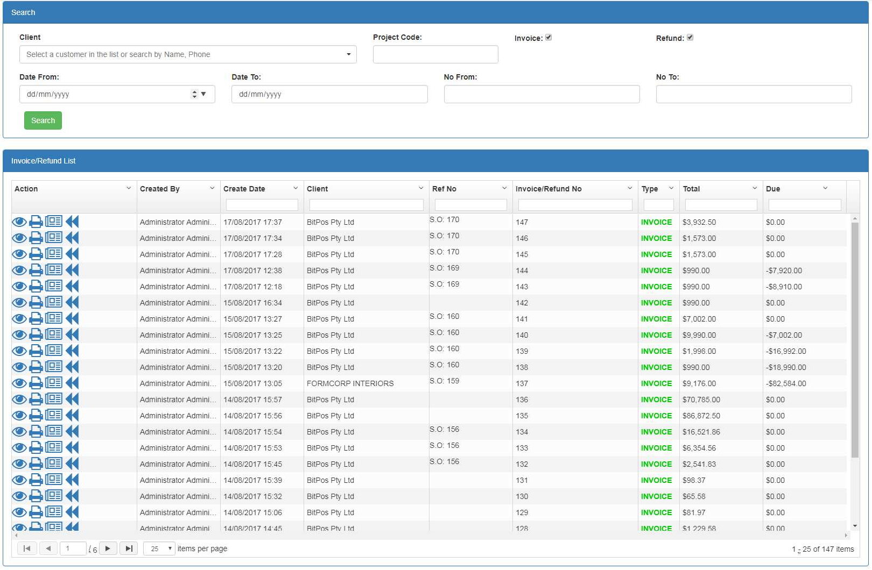

User can search for both Invoices and Refunds from this page

### Field Description

|  |  |
| --- | --- |
| Field | Description |
| **Search Criteria** | |
| Client | Dropdown Box – Limits the display to those Invoices that belongs to  the selected Client |
| Project Code | Entry Box- search invoices belong to this specific project code |
| Invoice | Check Box – if checkbox is ticked, the matched Invoices will be  included in search result |
| Refund | Check Box – if checkbox is ticked, the matched Refunds will be |

|  |  |
| --- | --- |
|  | included in search result |
| Date From | Date Box - Limits the display to those records that creation date is after  value entered for Date From |
| Date To | Date Box - Limits the display to those records that creation date is  before value entered for Date To |
| No From | Entry Box - Limits the display to those Invoices that no is after value  entered for No From |
| No To | Entry Box - Limits the display to those Invoices that no is before value  entered for No To |
| **Sale Order/Quote List –** the empty box beneath each field is for filtering the list | |
| Created By | Display-The user responsible for creating Invoice/Refund |
| Create Date | Display- Creation Date associated with the Invoice/Refund |
| Client | Display- Client associated with Invoice/Refund |
| Ref No | Display-  For Invoice : displays the sale order no that invoice is created from For Refund: displays the Invoice no that has been refund |
| Invoice/Refund no | Display – Invoice/Refund number |
| Type | Type of the record. Invoice or Refund |
| Total | Total value of Invoice/Refund |
| Due | Due amount of Invoice/Refund |
| Action | : open invoice/refund for view only  : open sale invoice/refund for view only  : print invoice/refund  : Refund the invoice ( applicable for invoices only) |

User need to enter the search criteria and then select the search option. The result will be displayed in the result list.

The result is displayed on pagination basis. The first page includes 25th matched records. User can navigate on other pages by selecting the navigation buttons



## Refund existing invoice

System provides this facility to refund part of invoice or whole invoice.

User can refund existing invoice by selecting  icon from Invoice list(for searching an invoice refer to Invoice/Refund list section).

By selecting the refund icon, the refund page appears populated with the selected Invoice data. Please note by default the Invoice data is appeared on the page.

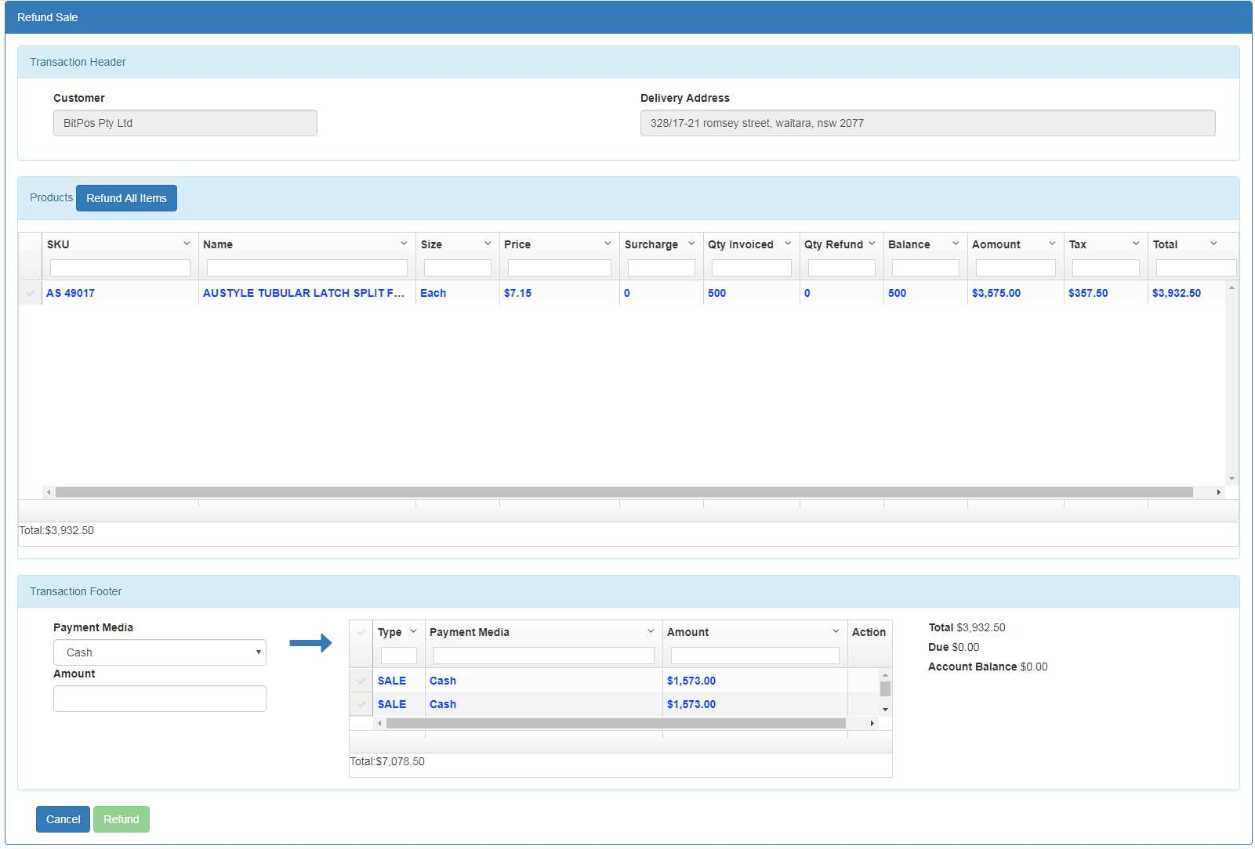

This page has two modes:

* Invoice Mode : this is the default mode of the page. It displays original invoice data (products and payments). Total, Due and Account Balance is related to the invoice
* 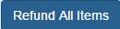Refund Mode : when items are selected for refunds(user can select items from product list by clicking  or select ) page mode change to refund. In this mode all the payments of refund appears and values for Total and Due get calculated based on the selected items for refund.

### Field description

|  |  |
| --- | --- |
| Field | Description |
| **Transaction Header** | |
| Customer | Display only – Customer who asked for an Invoice |
| Delivery Address | Entry Box – Customer delivery address. |
| **Products Lines –** the empty box beneath each field is for filtering the list | |
| SKU | Display Only – product sku |
| Name | Display Only- Product name |
| Size | Display Only- Product unit |
| Price | Editable box – product price |
| Surcharge | Entry Box – surcharge applies for refunding item |
| Qty Invoiced | Display Only – quantity requested in Invoice |
| Qty Refund | Entry Box- Qty customer wants to be refunded |
| Balance | Display only- Balance on the invoice ( Qty Invoiced – all Qty Refunded) |

|  |  |
| --- | --- |
| Amount | Display Only- line value  In Invoice Mode : amount = (qty invoice * price) In Refund Mode: amount = (qty refund * price) |
| Tax | Display Only – tax amount applies on product. This is calculated based on the number of taxes assigned to the product and the tax values  from product page |
| Total | Display Only – Total amount(net value include tax) need to be paid/refund for this line  In invoice mode : total = qty invoiced * ( price + tax)  In Refund Mode : total = qty refund * ( price + tax) |
| Transaction Footer | |
| Payment Method | Dropdown box: Payment method for example:  Cash, Cheque, Master card …. |
| Amount | Entry Box – Amount is going to be paid by selected payment method |
|  | To add payment amount to the payment list. user can pay with multiple payment method. For example some portion with cash, some portion with card or cheque and some portion from Account. For each payment, user need to select Method and amount and then add it to  the payment list by clicking on the botton or pushing the ‘Enter’ key. After adding to the payment list, the Due amount will be modified  according to the payment made. |
| Total | The total amount of Invoice/Refund |
| Due | Due amount of Invoice/Refund |

To refund items user need to follow these steps:

1. User selects item need to be refunded by clicking on checkbox at the left side of the products. User can also select all products for refund by clicking on 
   1. If user selects  the Qty Refund for all items is set to equivalent Qty Invoiced and the Amount and Total values change to negative.
   2. If user selects the item by clicking the  checkbox, user need to enter the value for Qty Refund and then the Balance, Amount and Total values will be calculated by system. User can’t enter quantity more than balance. Balance indicates the quantity has not been refunded on the item.
   3. For those items that had been totally refunded (all quantities are refunded) , the  checkbox is disabled and user can’t select items.
2. By selecting items for refund, the Total and Due value is calculated by system and appears at transaction footer section.
3. User need to add payments from payment section. User can do multiple payments . For doing a payment, select Payment Method and enter amount need to be paid and then select

button or push the ‘Enter’ key. The payment is added to the payment list and Due amount is changed accordingly. User can repeat this step for doing multiple payment with different payment media

If needed, user can delete a payment from payment list by clicking on button. The Due amount will change accordingly

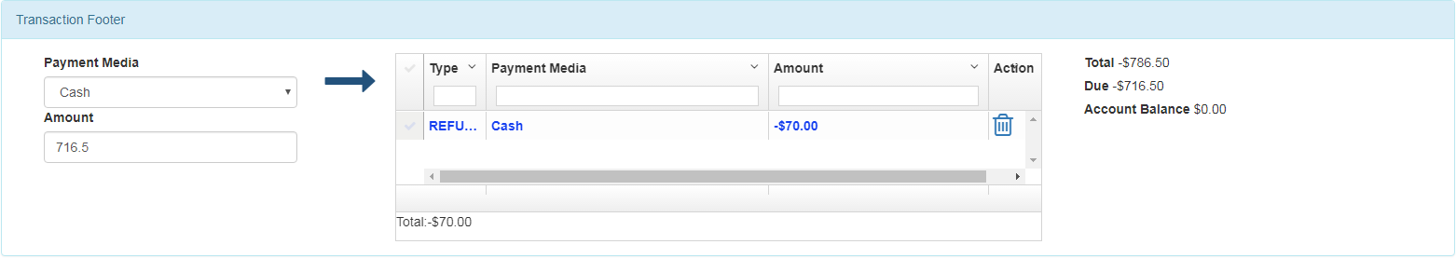

1. After paying Due value, User can select option. System refunds the selected items and create a new refund transaction. The refund transaction will be displayed for print.

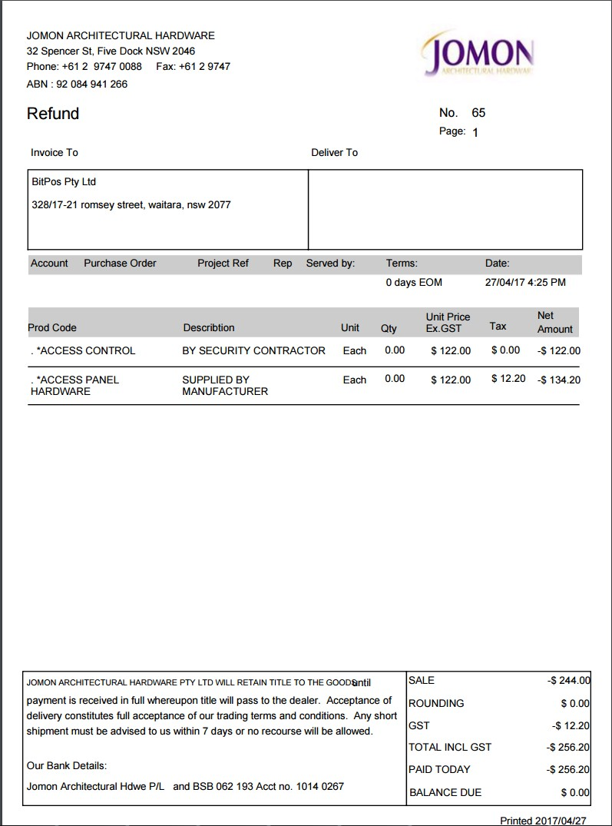

# Cash Management

For accountability purpose each user is assigned a cash session. When user logs in to the system, the session is opened and all transactions created by the user assigned to the session. When user signes off the session state is changed to close.

Sessions control cash (and other payment media) in cash drawers and are the direct responsibility of an Operator. A Session has a unique identifier associated with it. When an Operator signs on within a Session its status is “Open” and transactions are made against it. If an Operator signs off the status becomes “Closed”, but may revert to “Open” at a later time. When the Operator has completed trading in a Session, the Session is completed (end session) and the status becomes “Ended”. Once a Session is “Ended” the drawer contents may be declared and reconciled against the expected values calculated by the system from the transactions; this does not have to be done immediately. When the reconciliation is complete the Session status is “Reconciled”.

## View Cash Session List

To view all sessions, select ‘Session List’ from menu

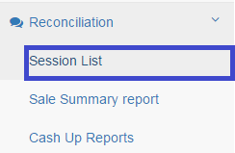

The following list appears

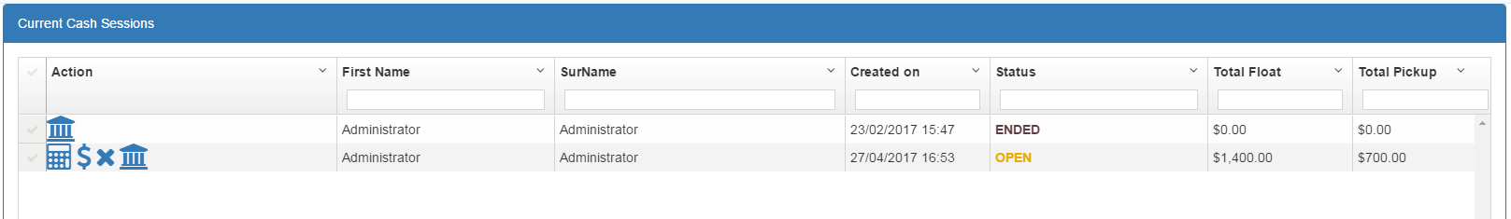

### Field Description

|  |  |
| --- | --- |
| Field | Description |
| **Cash Sessions** | |
| First Name , Surname | Display Only – the full name of operator is responsible for the cash  session |
| Created on | Display Only- the date/time session is created |
| Status | Cash Session Status:  : cash session is open and active- the transactions made by user will be logged against this session  : the session is Ended but not reconciled. No more  transaction will be logged against this session |

|  |  |
| --- | --- |
|  | Close: the transaction is closed. This is because the user has logged  off. When user logged in again, it will be changed to open Reconciled: the session had been reconciled |
| Total added float | Total amount added to the Register/Till. |
| Total Pickup | Total amount picked up by the user from Register/Till |
| Action | : Add Float – adding money to the Register/Till  : picking up money from the Register/Till  : End Session   * : Reconcile Session |

### Adding Float to Register/Till

To adding float to the Register/Till, from the session list, user selects adding float sign( ) for specific session. The ‘Add Float’ page appears:

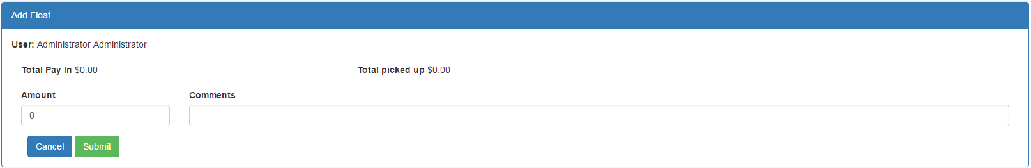

user full name, Total Pay In and Total Pickup amount for the current session appears on top of the page. User enters the Amount and a reason for it and the selects the ‘Submit’ button’. The total amount added to the session(Till/Register)

### Pickup Float

For picking up money from Till/Register, from the session list user selects pickup floats ) for the specific session. The ‘Pickup Float’ page appears:

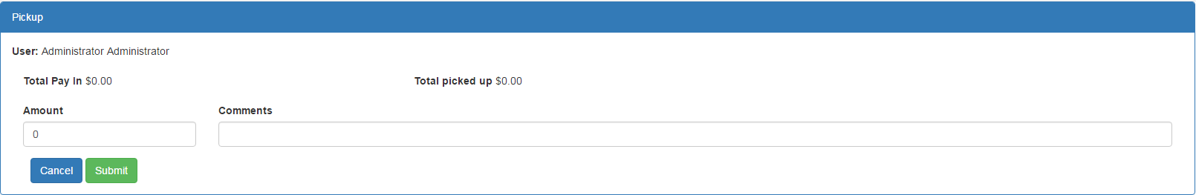

user full name, Total Pay In and Total Pickup amount for the current session appears on top of the page. User enters the Amount and a reason for it and the selects the ‘Submit’ button’.

### Reconcile Session

To reconcile a session from the session list, user selects reconcile session sign( ) for specific session. The ‘Reconcile Session’ page appears:

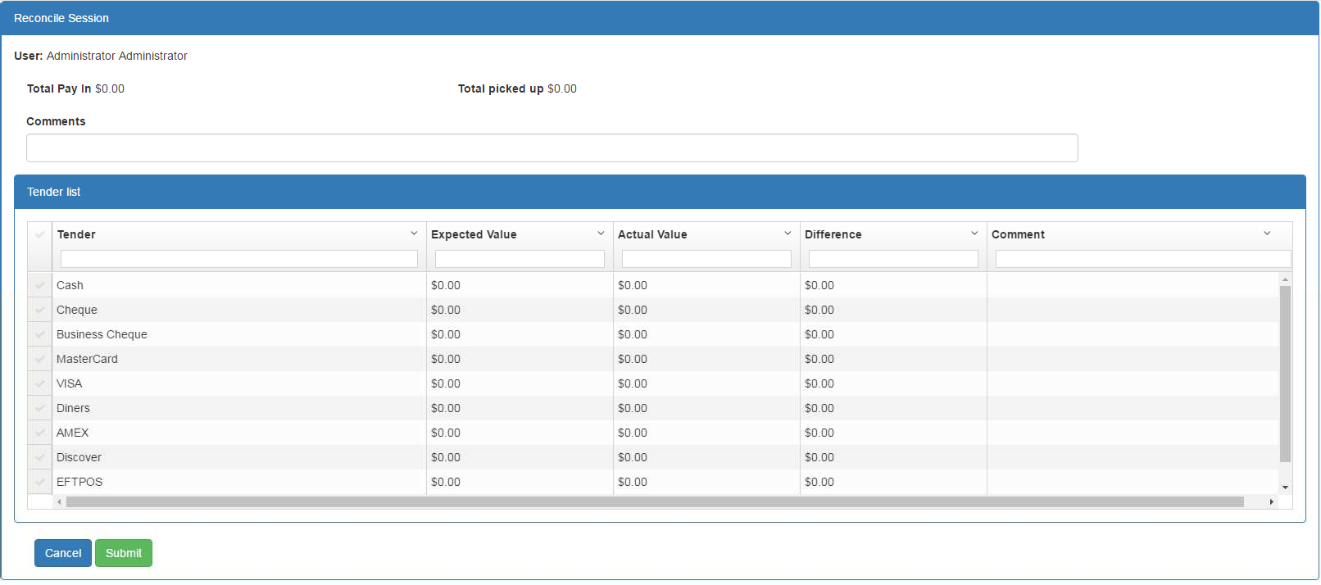

|  |  |
| --- | --- |
| Field | Description |
| **Reconcile Session page** | |
| Comments | Entry Box – and description or comments added by user |
| **Tender List** | |
| Tender | Display Only- Tender list |
| Expected Value | Display Only- Calculated value by the system for that tender which  should be exists in the Register/Till |
| Actual Value | Entry Box – Actual value that is counted by the user. |
| Difference | Display Only – difference between Actual and Expected value |
| Comment | Entry Box- reason for any discrepancy between actual and expected  value |

User need to enter the Actual Value and comment(reason if there is a difference) for each Tender and enter general comment(if required) for reconciliation and then select ‘Submit’ button. The session will be reconciled and reconciliation amounts will be registered for further actions.

## 9.2 Cash up Reports

For reconciled sessions, user can get Cash up reports or reconciliation reports. Cash up reports contains expected and actual values per each tender for that session.

User selects ‘Cash Up Reports’ from menu

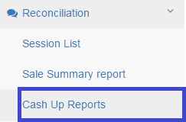

List of the reconciled session appears

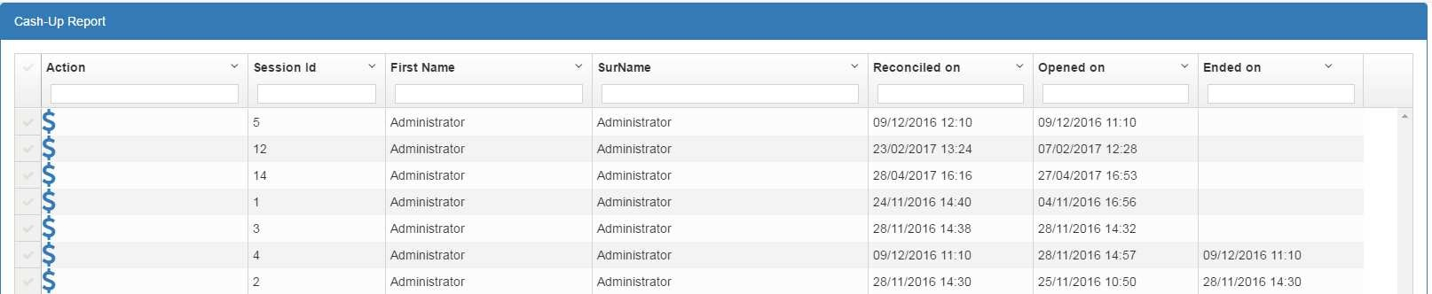

User can run view cash up report by selecting from list for that specific session. The cash up report appears as following:

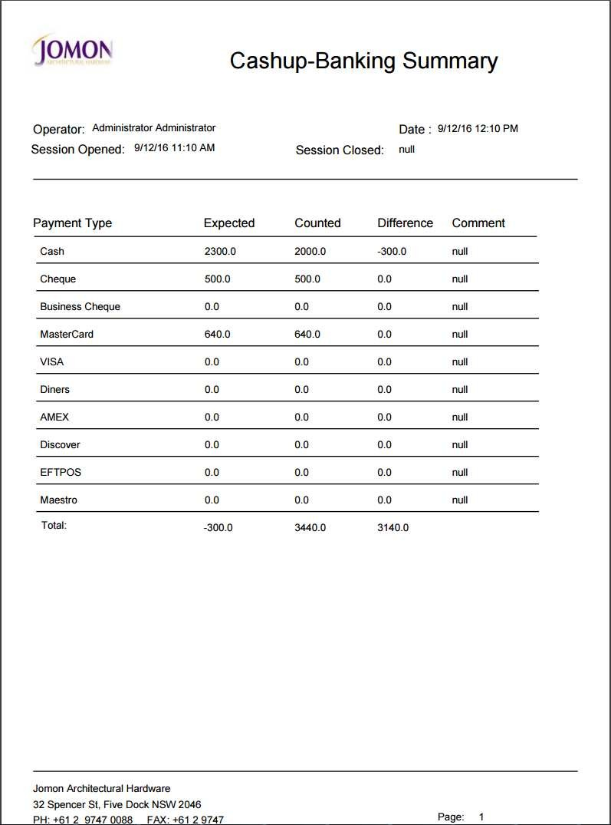

# Debtor Payment

We have two types of customers.

* Cash Only Customer: These customers don’t have any Credit account in company and they need to pay their invoices by cash
* Account Customer : Account customers have a Credit Account in company. The company set the Credit amount to a specific limit and customer can pay from their account. Customer can pay off his debt later based on the duration is set for the customer

The Account is set for the customer in customer page



Debtor payment provides facility to pay the customer’s debt.

User need to select ‘Debtor Payment’ from menu. System displays ‘Debtor Payment’ page

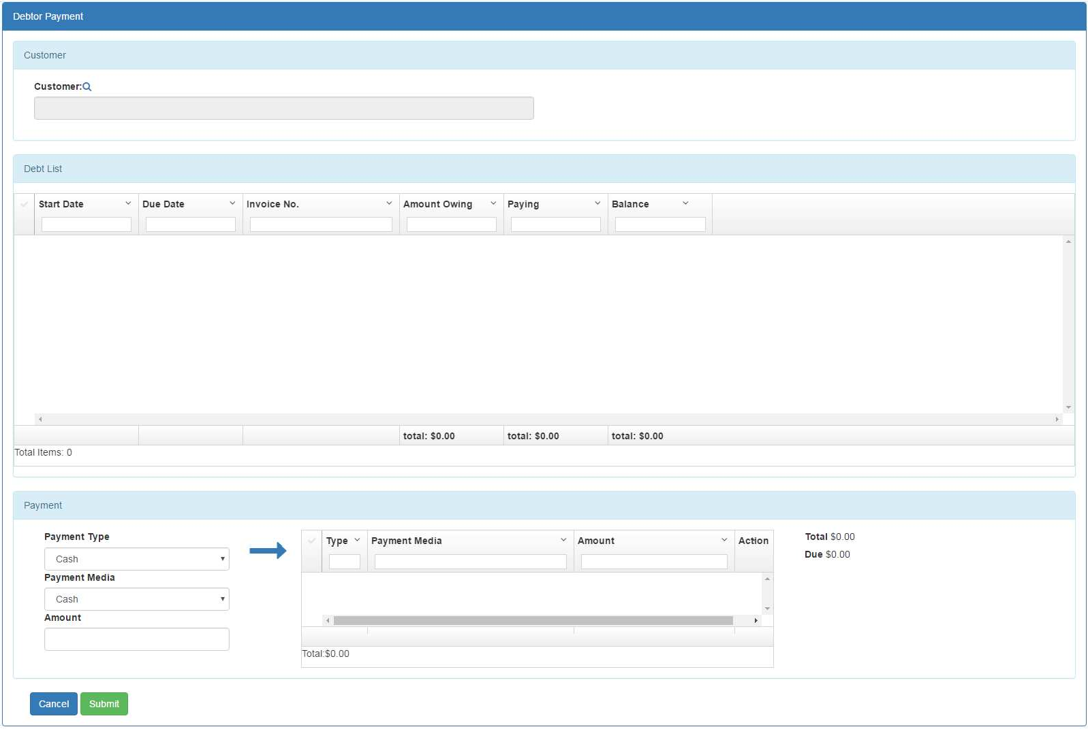

Field Description

|  |  |
| --- | --- |
| Field | Description |
| **Customer** | |
| customer | Search Box – search the customer |
| **Debt List** | |
| Start Date | Display Only- The date of transaction payed from Account |

|  |  |
| --- | --- |
| Due Date | Display Only- Due date for paying off the debt – calculated by the system. If ‘Start From EOM’ in customer page is ticked, the due date is calculated based on End Of Month when transaction is committed  otherwise it is calculated from the transaction date |
| Invoice No | Display Box – the invoice no paid from credit |
| Amount Owing | Display Only – amount paid by credit for that invoice |
| Paying | Entry Box- debt amount customer wants to pay now |
| Balance | Display Only – the balance amount customer still owe the company |
| Payment | |
| Payment Type | Dropdown box : paymet method can be cash, cheque, card,… |
| Payment Media | Dropdown box: for each payment method, there might be different media. For example for card payment we have Master Card, Visa,  Dinners … |
| Amount | Entry Box – Amount is paid by selected payment method |
|  | To add payment amount to the payment list. user can pay with multiple payment media. For example some portion with cash, some portion with card or. For each payment, user need to select Type, Media and amount and then add it to the payment list by clicking on  the botton. After adding to the payment list, the Due amount will be justify according to the payment made. |
| Total | Total amount which need to be paid today |
| Due | Due amount that need to be set by paymet |

### For debtor payment:

1. user select the customer by clicking on search button ( ).
2. System displays the list of customer to select from. User can filter this list by different fields and then select the customer by clicking on ) on left side of the list and then select confirm )

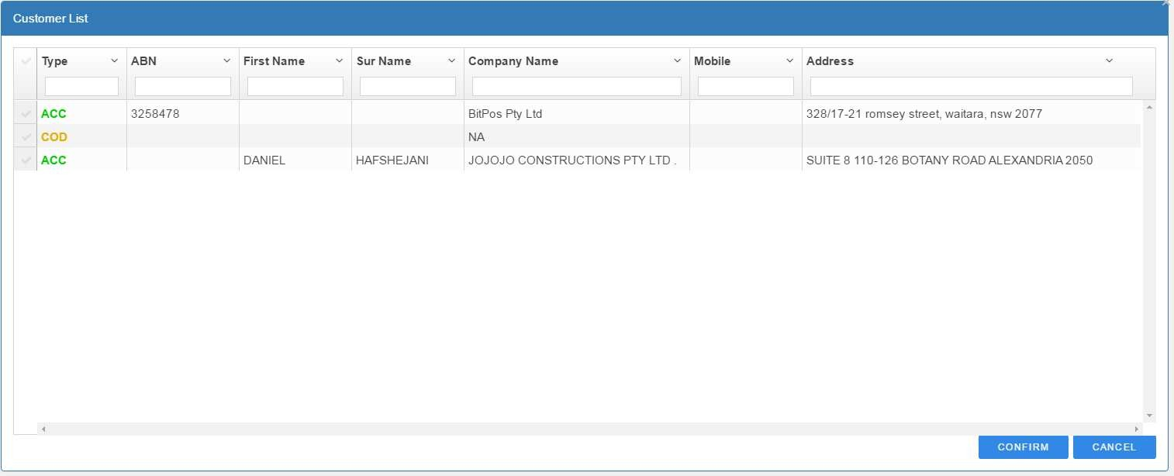

1. All the customer debts and related invoice no are displayed on Debt List section of ‘Debtor Payment’ page

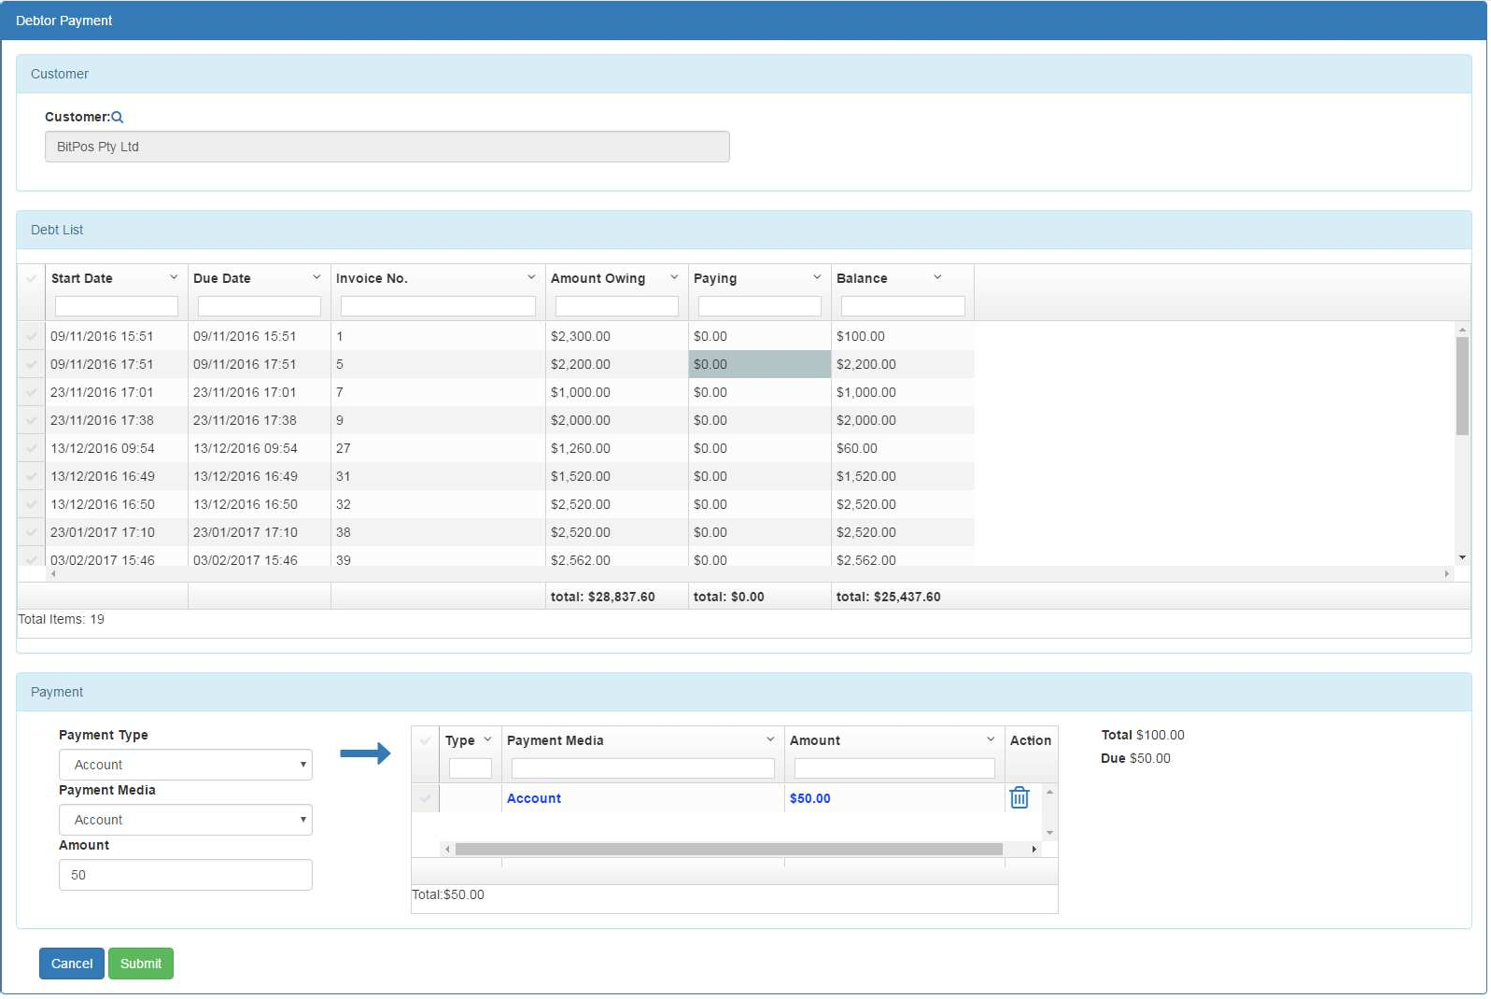

1. User enters the paying amount for each invoice in ‘Paying’ field of Debt List. the ‘Total’ value displays the summation of ‘Paying’ amount entered by the user.
2. User need to add payments from payment section. User can do multiple payments . For doing a payment, select Payment Type, Payment Media and enter amount need to be paid

and then select button. The payment is added to the payment list and Due amount is changed accordingly. User can repeat this step for doing multiple payment with different payment media

1. If everything is ok, user can submit the payments by selecting ‘submit’ )

# Accounting

This section provides facility to define accounting chart and generate accounting report.

When user submits different transactions(invoice, sale order, purchase order, good received and reconciliation) system creates accounting journal entries based on the accounting chart configured in the system.

After a session is reconciled, the accounting report is accessible.

## Configure Accounting Chart

From menu select ‘Accounting Chart’.

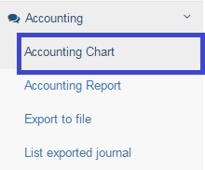

The ‘Accounting Chart’ page displays:

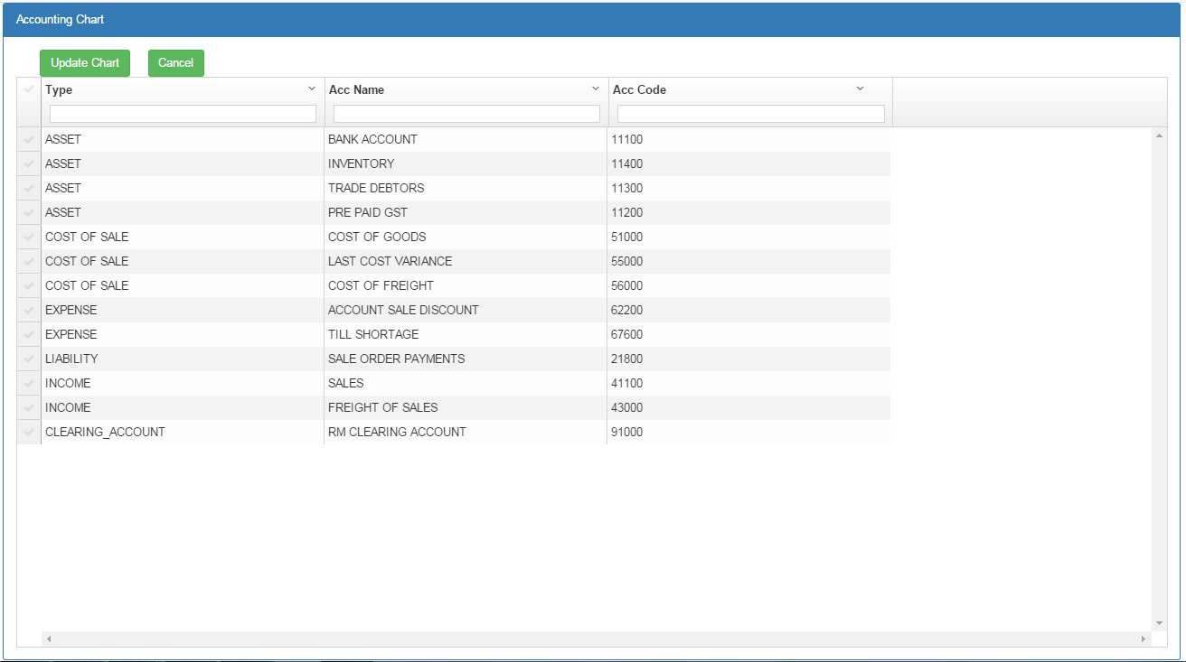

the chart includes all the account’s detail including type, name and code. Account type and name are predefined in the system and can’t be changed but user can change the account code.

After changing the account code, by selecting ‘Update Chart’ 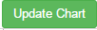 the changes will be applied to the system.

## Accounting Report

Accounting report can only be generated for reconciled sessions. for reconcile a session please refer to reconciliation section

For generating report select ‘Accounting Report’ from Accounting menu

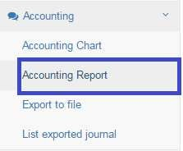

Accounting report appears :

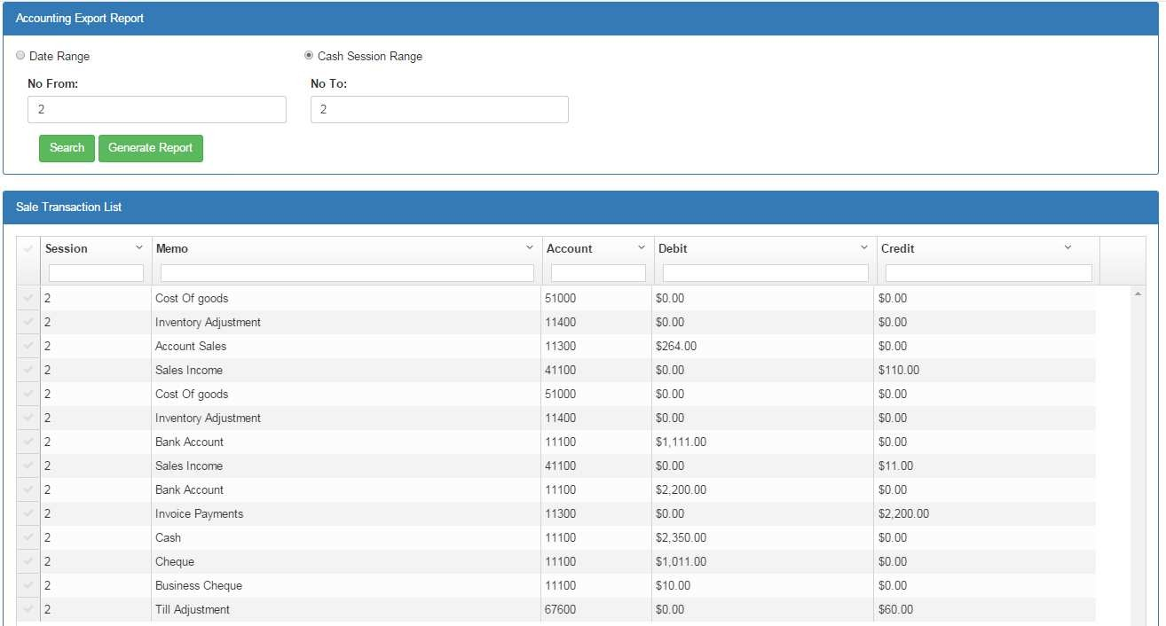

Field Description

|  |  |
| --- | --- |
| Field | Description |
| **Accounting Report Header** | |
| Date Range | Radio Box – if ticked search range will be based on date range |
| Cash Session Range | Radio Box – if selected, search range will be based on cash session  range |
| **Sale Transaction List** | |
| Session | Display Only – cash session number |
| Memo | Display Only –Journal Entry Description |
| Account | Display Only –Account code |
| Debit | Display Only –Amount account is debit |
| Credit | Display Only –Amount account is credit |

User can generate the report based on the date range or cash session range.

If user select ‘date range’ radio button( ) system allow user to select from date range:

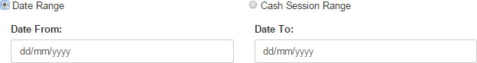

If user select ‘Cash Session Range’ system will allow user to select from cash session range:

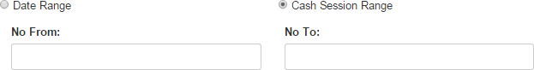

User enters the rage and then selects the ‘Search’ button. System will display all the journal entries related to the selected range.

By selecting ‘Generate Report’ ) the PDF report will be displayed for selected range:

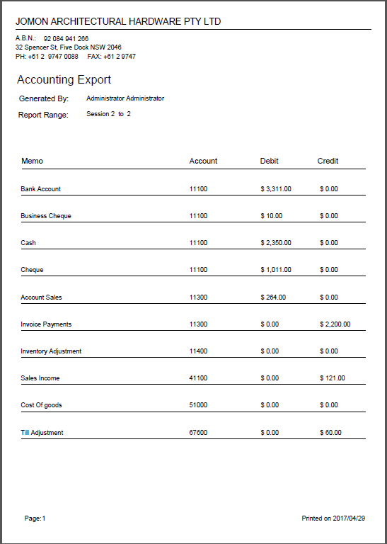

## Export to file

System also can generate Accounting Journals in text format readable by MYOB Accounting System. For exporting to journal accounts into file select ‘Export to file’ from menu

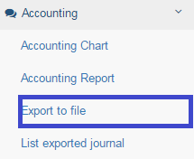

The ‘Export to File’ page appears:

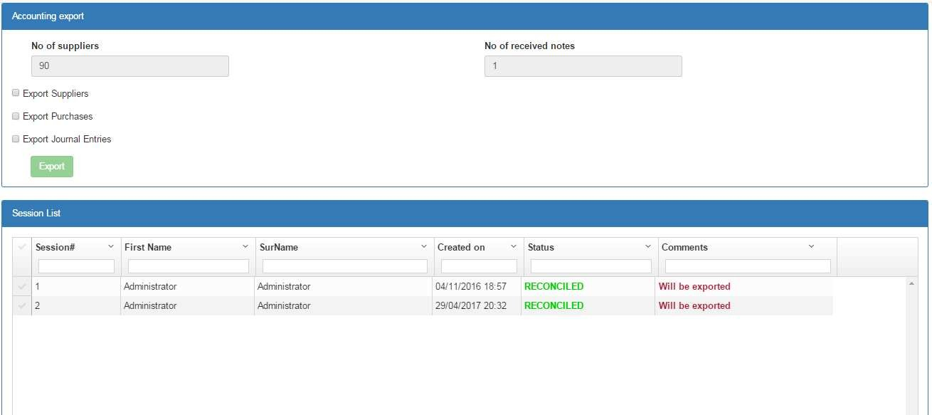

### Field Description

|  |  |
| --- | --- |
| Field | Description |
| **Accounting Export Header** | |
| No of suppliers | Read only – no of suppliers had not been exported yet – these  suppliers will be exported in this export |
| No of received notes | Read only – no of received notes had not been exported yet –  these received notes will be exported in this export |
| Export suppliers | Check box – suppliers not been exported before, will be exported  in this export |
| Export purchases | Check box – purchases not been exported before, will be exported  in this export |
| Export journal entries | Check box – journal entries not been exported before, will be  exported in this export |
| **Session List – (view only)displays cash session list and their export status** | |
| Session# | Display Only –Session no |
| First Name/Surname | Display Only –full name of user responsible for session |
| Created on | Display Only –the date session is created |

|  |  |
| --- | --- |
| Status | Display Only – the status of cash session |
| Comments | : all the journal entries assigned to this session will be exported in this export  : journal entries assigned to this session had been exported before – this session will not be exported |

As can be seen on the page, three different items can be exported from the system:

* **Suppliers** : supplier’s data for those suppliers had not been exported before, will be exported in this export
* **Received notes** : received note’s data for those received notes had not been exported before, will be exported in this export
* **Journal entries**: journal entries data for those suppliers had not been exported before, will be exported in this export

No of suppliers and received notes not been exported before is displayed on the top of page. Also for reconciled sessions, the export status will be displayed at the bottom of the page. Those session will be exported in this export will be marked as 

For export, user need to tick the items need to be exported

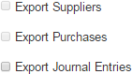

And then select ‘Export’ option.

System will generate the export file in text format and display it to the user.

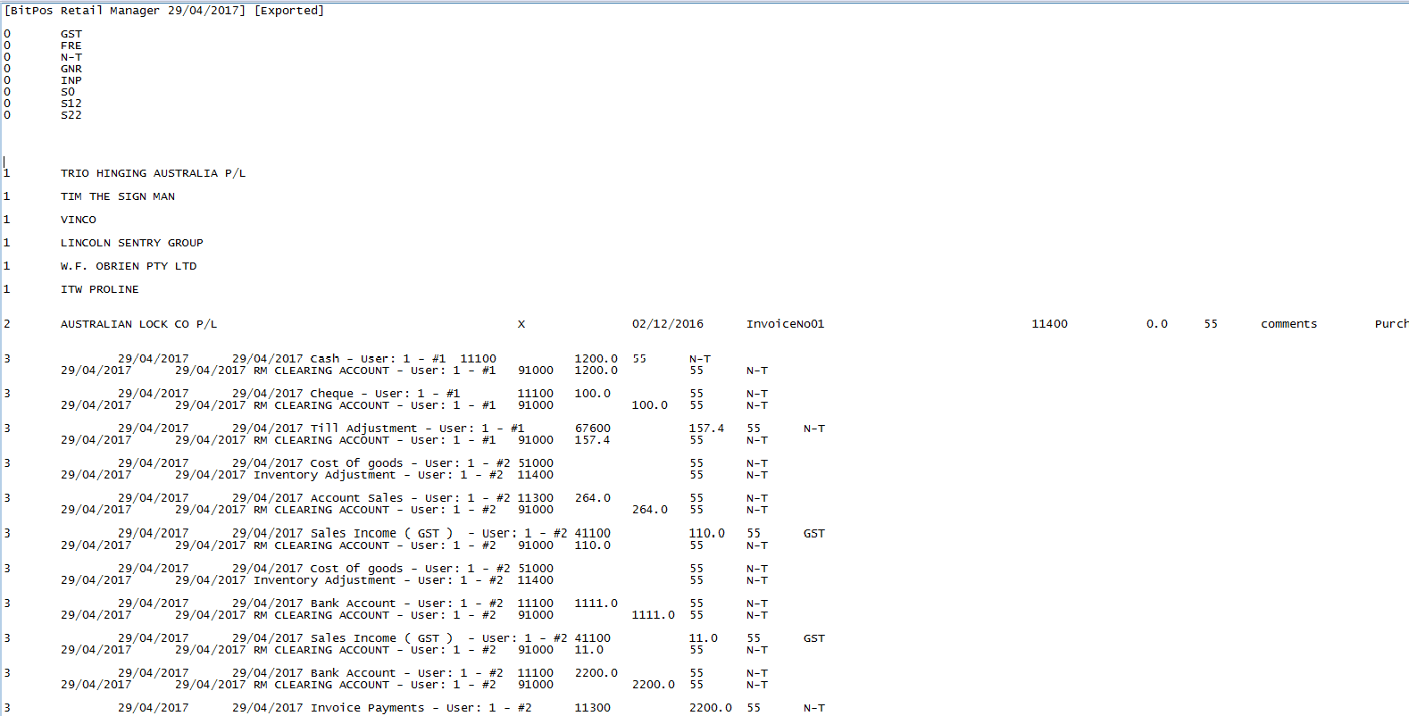

This text file can be used by MYOB Accounting system for importing.

## View exported journals

System stores all exported accounting files for further access. User can access to these files by selecting ‘List Exported Journals’ from menu

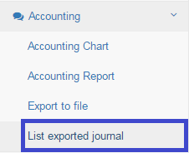

All the exported files will be displayed:

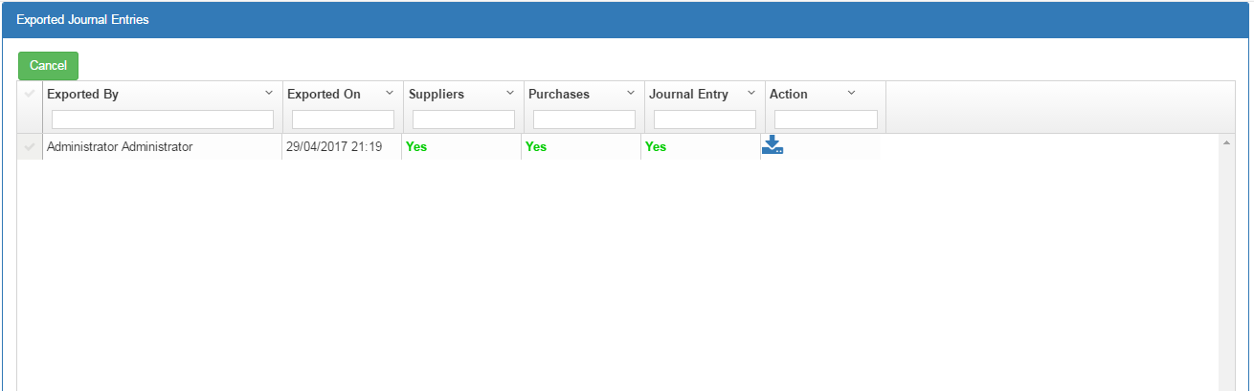

### Field Description

|  |  |
| --- | --- |
| Field | Description |
| **Exported Journal Entries** | |
| Exported by | Read only – user who exported the accounting file |
| Exported on | Read only – date file had been exported |
| suppliers | Yes : suppliers are exported in this file  No : suppliers not exported in this file |
| purchases | Yes : received notes are exported in this file  No : received notes not exported in this file |
| journal entry | Yes : journal entries are exported in this file  No : journal entries not exported in this file |
| Action | : download the stored file |

System displays all the exported files and their properties (who created file and content of the file) User can access to the file by selecting icon. The file will be downloaded from the server.

# Configuration

## Pricing grades

The selling price is based on product cost and customer grades. There are predefined different rules as below:

1- **RRP - %** : selling price is RRP(defined in product page) with a percentage of discount. 2- **RRP - $**: selling price is RRP(defined in product page) with a fixed amount discount. 3- **Cost + %**: selling price is product cost plus a percentage of cost

4- **Cost + $**: selling price is Product cost plus a fixed amount 5- **Fixed $** : selling price is a fixed amount

By this facility, user can assign a pricing rule to specific predefined grade and then assign the grade to customer in ‘Customer Page’.

For defining customer grade, select ‘Pricing Grades’ from Configuration menu:

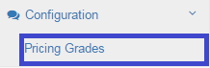

System displays ‘Pricing Grades’ page as below:

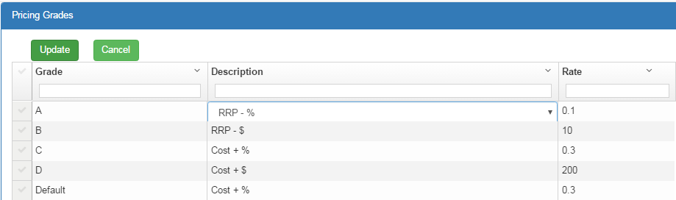

|  |  |
| --- | --- |
| Field | Description |
| **Pricing Grades** | |
| Grade | Display – Predefined grade code |
| Description | Dropdown- Predefined pricing rule.  By double clicking on this field, user can change the pricing rule |
| Rate | Entry Box- the rate amount for this rule |

For each grade:

1. select a rule by double clicking on ‘Description’ column(and select from the dropdown menu)
2. select the grade

then select  if you want to apply rules in the system.

# Import

System provide this facility to import data from Doors3 and MYOB Retail Manager. the following data can be imported to the Pos system:

* Customer data exported from MYOB Retail Manager
* Supplier data exported from MYOB Retail Manager
* Product data exported from Doors3
* Bill Of Quantity data exported from Doors3

## Import Customer data

System provides facility for importing customers from MYOB Retail Manager. The customer list exported from MYOB need to be converted to csv format before importing to the Pos system. The csv file must be in the following format exported from MYOB:

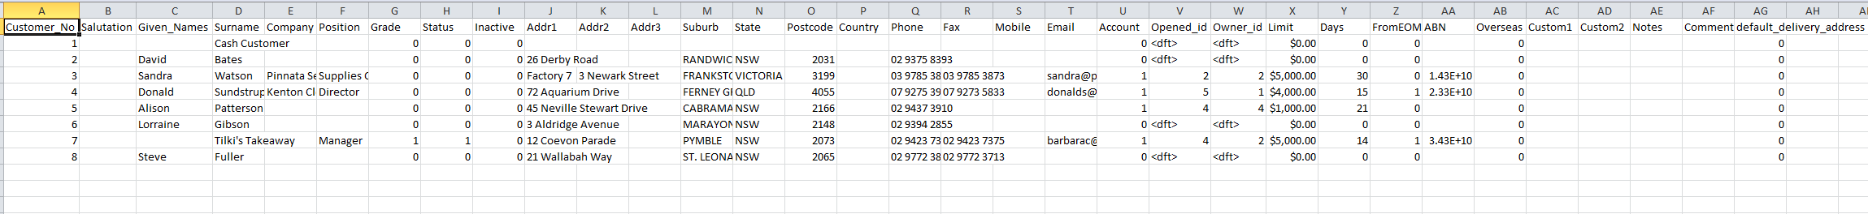

To import the customer list:

Select ‘Import Customer from MYOB’ option from Import menu.

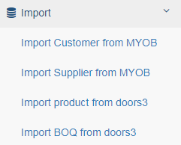

System displays ‘import customer’ page.

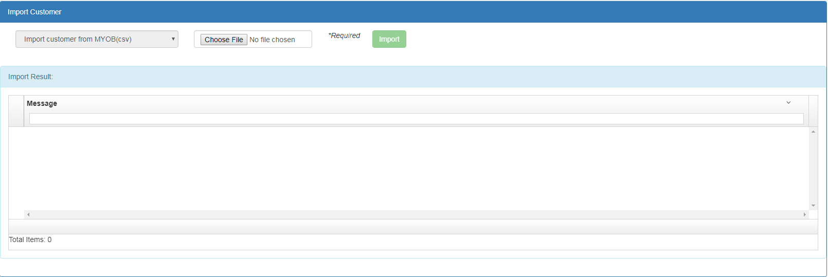

User need to choose file from file system by clicking on and then selecting option.

System will display the result in ‘Import Result’ section.

## Import Supplier data

System provides facility for importing suppliers from MYOB Retail Manager. The supplier list exported from MYOB need to be converted to csv format before importing to the Pos system. The csv file must be in the following format exported from MYOB:



To import the supplier list:

Select ‘Import Supplier from MYOB’ option from Import menu.



System displays ‘import supplier’ page.

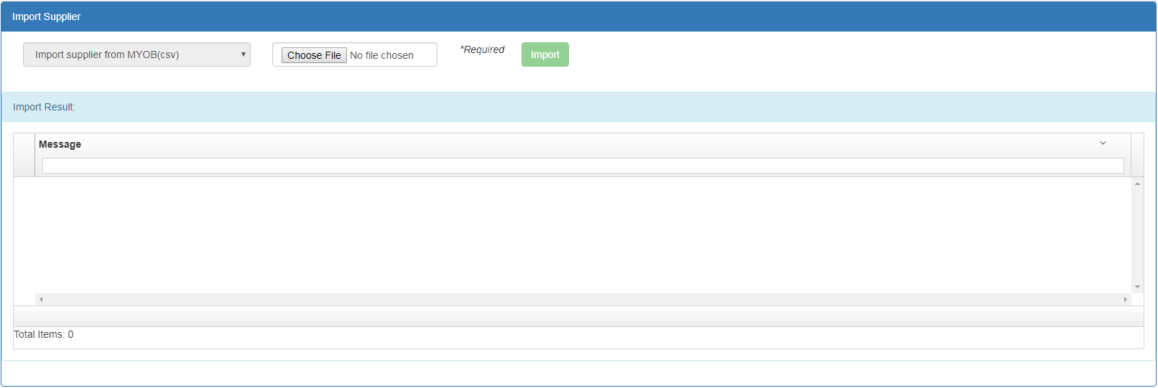

User need to choose file from file system by clicking on and then selecting option.

System will display the result in ‘Import Result’ section.

## Import Products

This section provides facility for importing products in csv format. The csv file must be in the following format:



Select ‘Import Product from doors3’ option from Import menu.



System displays ‘import product’ page.

The ‘Import product’ page appears as below:

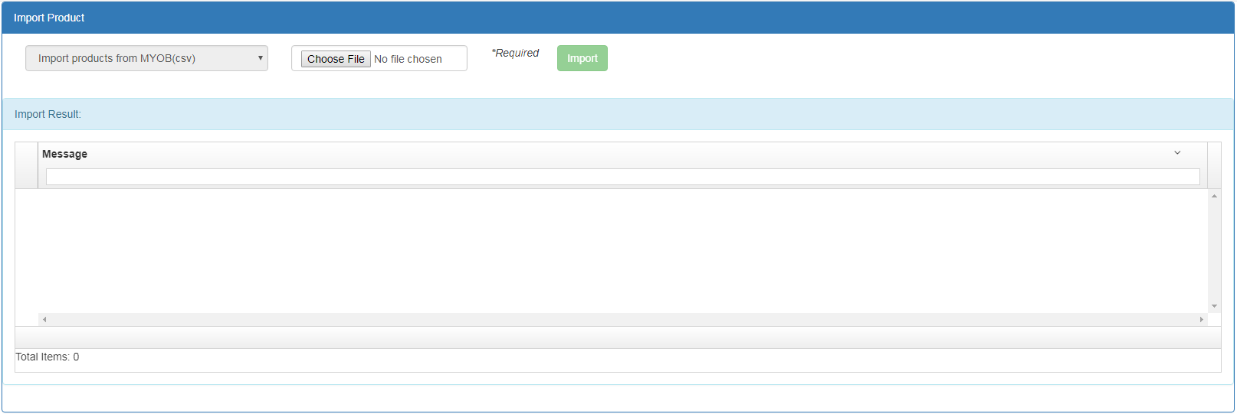

User need to choose file from file system by clicking on and then selecting option.

System will display the result in ‘Import Result’ section.

The product keys for importing are SKU and Reference. When importing a product, if there is an existing product with same SKU and Reference, then the product is considered as existing one and only the supplier will be added to the product supplier list. if no matching product not found with the same SKU and Reference, then product will be imported to the system.

## Import BOQ from doors3

System provides facility for importing Bill Of Quantities from doors3. The boq list exported from doors3 need to be in xml format. The xml file must be in the following format exported from doors3:

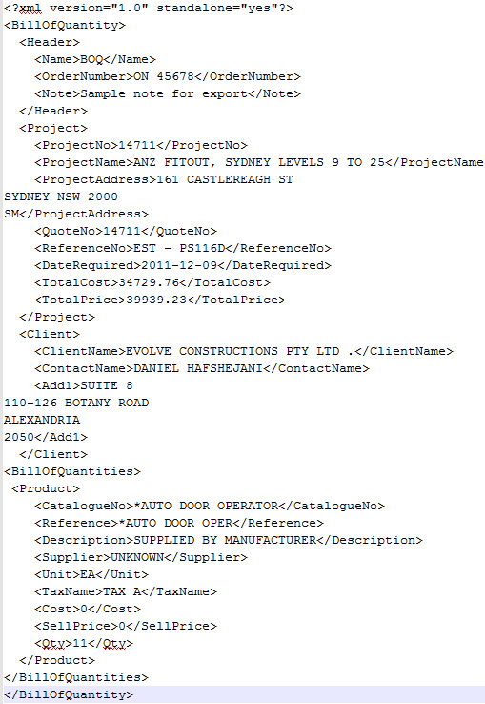

To import the BOQ list:

Select ‘Import BOQ from doors3’ option from Import menu.



System displays ‘import Bill Of Quantity’ page.

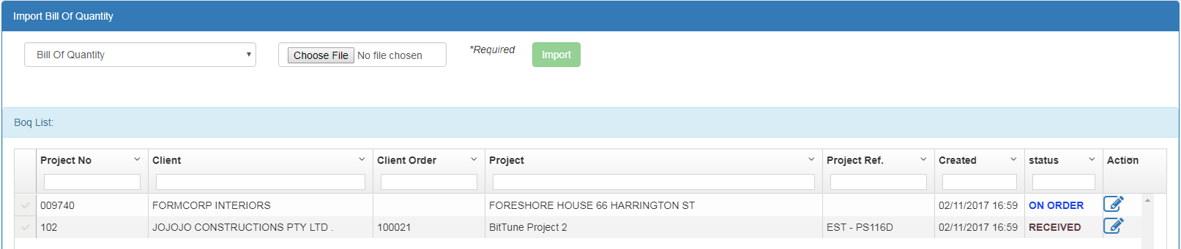

User need to choose file from file system by clicking on and then selecting option.

System will display the imported boq in ‘Boq List’ section.